BLISTER CARE

Blisters are common in all sports and occur in areas of increased friction. Friction causes heat and when the body senses that – it responds by sending water to the area to cool it off. This fluid fills the affected area produces a separation of the layers of the skin. When this separation occurs, a pocket of fluid builds up between the outer layer and inner layer of the skin. Often times this fluid is water, but can also contain blood or pus. If a blister contains white or yellow pus, medical attention is needed.

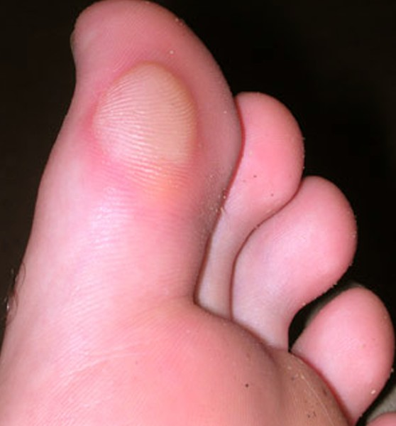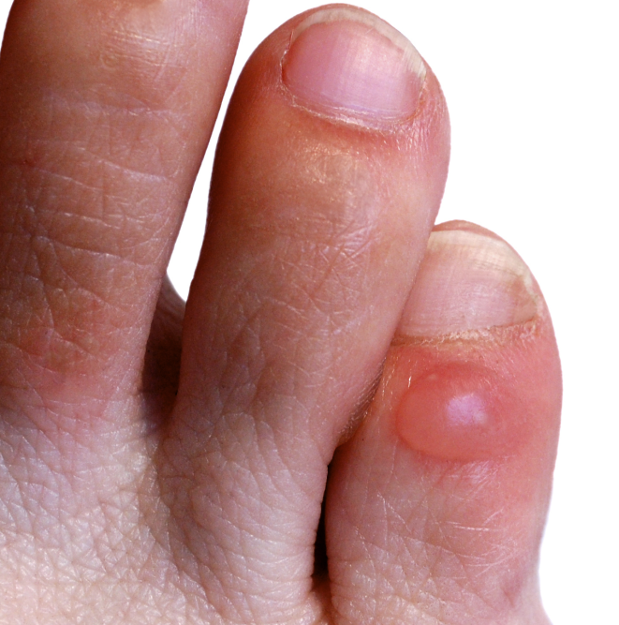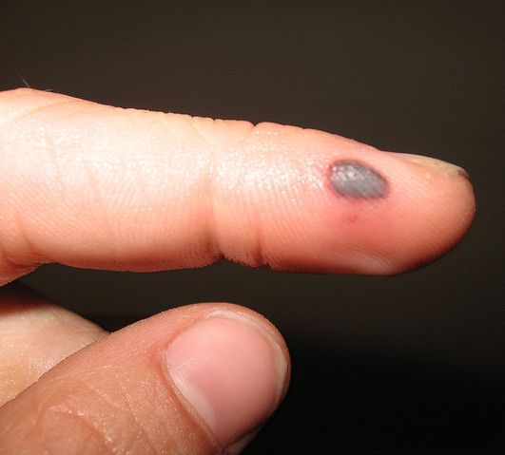

What causes a blister?:

Blisters can occur for a variety of reasons, but friction blisters are most commonly seen in sports due to the rubbing of athletic equipment. This friction between the skin and equipment pulls the outer layers of the skin apart creating a pocket of fluid. This separation leaves the surface of the skin undamaged, which protects the underlying skin, allowing it to grow. As this skin heals, the outer layer of the skin eventually dries out, and the blister resolves on its own.

Treatment:

The best course of treatment for a friction blister is to allow the blister time to heal on its own, which may occur in as little as 2-3 days. To keep the blister intact, a blister pad and bandage can provide protection and pain relief. If a blister has broken on its own, follow the steps on figure 1 for treatment. If a blister causes too much pain and pressure due to the build-up of fluid, it may be helpful to drain the blister. It is important to keep the wound clean to avoid infection. Once a blister is popped, or broken, it is considered an open wound at risk for infection.

Figure 1.

Steps to Manage an Open Blister
- Wash your hands and the blister with antibacterial soap and warm water
- Apply Vaseline or an antiseptic cream to the blister and cover with a Band-Aid, blister pad, or non-stick gauze
- Clean, apply ointment, and bandage daily

Figure 2.

Steps to Drain a Painful Blister
- Wash your hands and the blister with antibacterial soap and warm water
- Gently wipe the blister with iodine or an alcohol wipe
- Sterilize a clean, sharp needle with rubbing alcohol
- Use the needle to puncture the an edge of the blister
*Never intentionally remove the top layer of skin – this protects the affected area from germs and
bacteria
- Allow the fluid to drain by gently massaging the blister
- Apply Vaseline or an antiseptic cream to the blister and cover with a Band-Aid, blister pad, or non-stick gauze
- Clean, apply ointment, and apply bandage daily

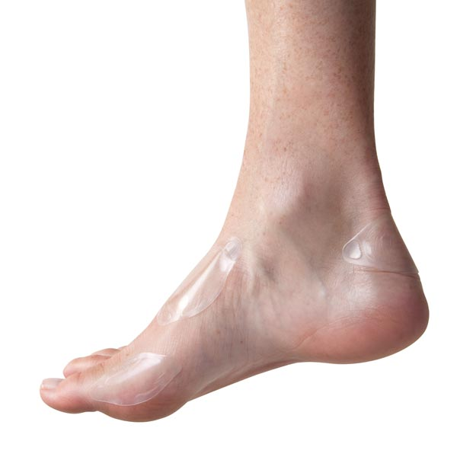

Prevention: Friction blisters most often occur on the feet and hands. In order to decrease the risk of a friction blister on the feet, wear shoes that fit well, and break in new shoes gradually. While breaking in shoes, blisters can be prevented by applying an adhesive bandage to areas that may rub, dust the inside of your socks with talcum powder, and/or wear moisture-wicking socks. To prevent friction blisters on the hands wear gloves or bandage areas that may rub due to friction or repetitive motions such as in weight lifting.

For more information please visit:

Mayo Clinic- http://www.mayoclinic.org/first-aid/first-aid-blisters/basics/ART-20056691
Blister Care - http://www.blistercare.org/
WebMD - http://www.webmd.com/skin-problems-and-treatments/understanding-blister-treatment

Consult your primary care physician for more serious injuries that do not respond to basic first aid. As an added resource, the staff at Children’s Sports Medicine is available to diagnose and treat sports-related injuries for youth and adolescent athletes. To make an appointment, call 402-955-PLAY (7529).

