DENTAL INJURIES AND THE ROLE OF MOUTH GUARDS

In young athletes, most of the dental injuries occur in contact and collision sports. The use of a well-fitting mouth guard can prevent virtually all of them. Below are the most common.

Avulsions:
These occur when the entire tooth, including the root, is knocked out.
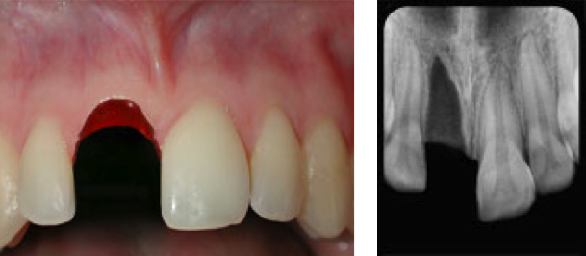
Use the following guidelines to help with a tooth avulsion:
- Handle the tooth by the crown, not the root
- Do not brush, sterilize, or scrub the tooth
- If tooth is dirty, gently rinse with water
- If possible, place tooth back in socket and have the athlete
gently bite down on a towel
- Immediately transport the athlete and tooth to a dentist.

Luxations:
These occurs when the tooth is still in the socket but in the wrong position.
There are three types of luxation’s:
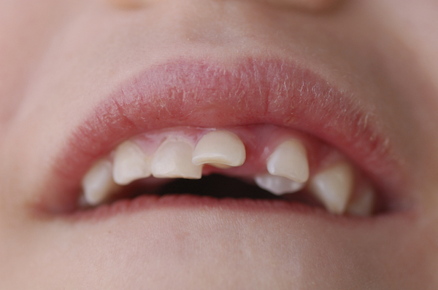
- Extruded Tooth: Tooth will appear to be longer than the
surrounding teeth. The tooth will need to be repositioned into
the socket using firm finger pressure. This is best done by
trained dental/medical personnel.
- Lateral Displacement: Tooth appears to be pushed back or
forward. No treatment should be provided at the scene of the
injury because the tooth is locked in bone. Transport immediately
to a dentist.
- Intruded Tooth: Tooth will appear to be pushed into the gums
and have a shorter appearance. No treatment should be provided
at the scene of the injury because the tooth is locked in bone.
Transport immediately to a dentist.
Fractures:
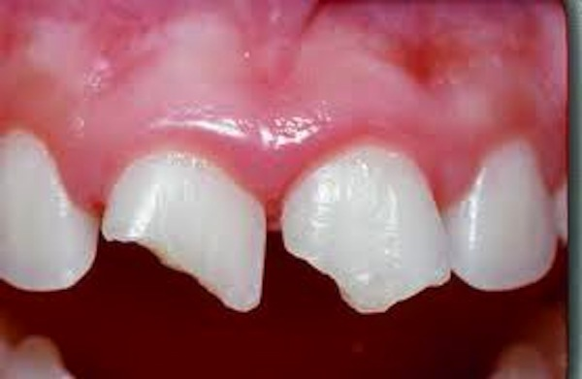
A fracture causes damage to the tooth itself and it will appear either
chipped or broken.
Use the following guidelines after a tooth fracture:
- If the tooth is in pieces, save the broken portion and bring
it to the dental office in water or milk.
- The nerve of the tooth may be exposed causing pain from
cold, heat, and air passage.
- The athlete may complete the game or activity but will
require dental treatment within 24 hours for definitive
care. The sooner you see a dentist the better.

The Role of Mouth Guards

Dental injuries can occur without the use of a mouth guard. Mouth guards help protect your teeth and mouth from injuries that can occur while playing sports. Dental injuries such as chipped or broken teeth, fractured crowns or bridgework, lip and cheek injuries, root damage to the teeth, and fractured jaws, can all be prevented by simply wearing a mouth guard.

Type | Ready-made or Stock | Mouth-formed “boil-and-bite” | Custom-made
Pros | - Least expensive  - Readily available at sporting goods stores | - Better fit than Stock mouth guards  - More protection than stock mouth guards  - Fairly consumer-friendly | - Tailored to the demands of the athlete and sport  - Most comfortable fit  - Provide best protection
Cons | - Limited sizes  - Only held in place by biting down  - Least amount of protection  - Can interfere with breathing and speech | - Tend to be bulky and uncomfortable  - Difficult to fit around braces  - Limited protection | - Most expensive
Examples | 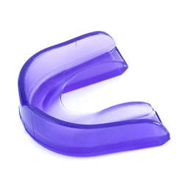 | 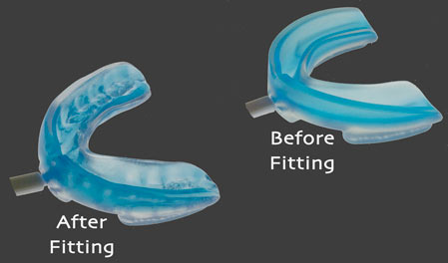 | 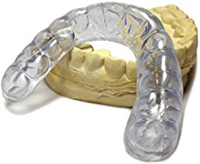

Recommendations
- Identify an oral health care specialist with additional training in sports dentistry for direct referral
- Ensure health care professionals providing sideline coverage carry a dental trauma pack
- Perform a concussion evaluation when orofacial exams are needed
- Educate health care professionals, athletes, parents, and coaches on the importance of mouth guards
- Understanding the concept of broad dental injury categories
- Encourage athletes to wear mouth guards when participating in sports with an increased risk of orofacial injuries
- Routinely inspect mouth guards for proper fit and durability or effectiveness
- Instruct athletes to sanitize their mouth guards regularly

For more information visit:

American Dental Association www.ada.com
National Athletic Trainers Association www.NATA.org
Academy of General Detistry www.agd.org

As an added resource, the staff at Children’s Sports Medicine is available to diagnose and treat sports-related injuries for youth and adolescent athletes. To make an appointment, call 402-955-PLAY (7529).

