Fit Fore the Fairway!

Golf is a relatively low impact sport to play. However, injuries can happen due to one-sided repetitive swinging. For young players to enjoy the game they should be flexible and strong. Core strength will help transmit the force generated from the lower to the upper body and reduce the stress on any one joint or muscle group. This not only increases overall force production and driving distance, but also helps improve endurance and delay fatigue.

Common Injuries:

According to the American Orthopaedic Society for Sports Medicine, 44 percent of youth golf injuries occur from overuse. These injuries tend to develop over time and are more subtle to recognize. They often stem from increases in physical activity load, decreased recovery time and/or improper mechanics. Many of these can be prevented with proper training and stretching. However, once an injury occurs, early intervention is key for optimal recovery and reduced time away from sport. Examples of overuse injuries in young golfers include: low back strains, shoulder pain and golfers elbow (tendinitis).

The progression of symptoms of an overuse injury follows a relatively sequential course and is described in 4 stages:
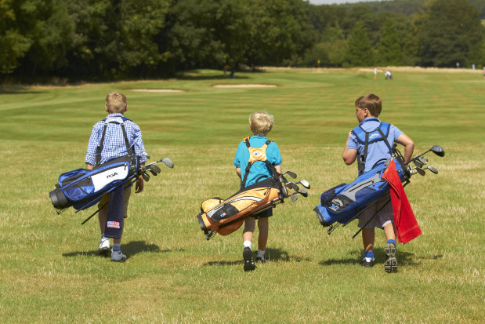

- Pain in the affected area after physical activity
- Pain during physical activity, not restricting
performance
- Pain during physical activity, restricting
performance
- Chronic, persistent pain, even at rest

It can be confusing to determine if the pain the young athlete is experiencing is from an injury or part of the physical toll of practice and play. Consider the progression of their complaints from these 4 stages.

Treatment:

Many overuse injuries can resolve with activity modification or rest. The “no pain no gain” philosophy will not help with these types of injuries and anything that causes pain can slow the healing process. However, during this time, the body can become weaker and less flexible which can set them up for additional challenges when returning to activity. To ensure proper healing, follow these treatment tips:

- Modify activity to remove the stress from the injured area and allow it to heal.
- Continue to work on overall pain free flexibility.
- Continue to work on core strength
- Continue to use proper mechanics and slowly increase activity.
- Consider starting on the driving range, progress to short game then proceed through irons to woods.
- Don’t modify swing to avoid pain!
Injury Prevention:

Golfing is similar to sprinting; it involves an explosive action that produces high force through the body over a short period of time. Cold muscles are prone to injury and limit range of motion. A proper warm up prepares the body for this force and helps prevent injuries and improve performance.

- Create a routine of targeted dynamic stretching. Lunge walking with reach back, Frankenstein’s, Spiderman’s and trunk twists are a good start

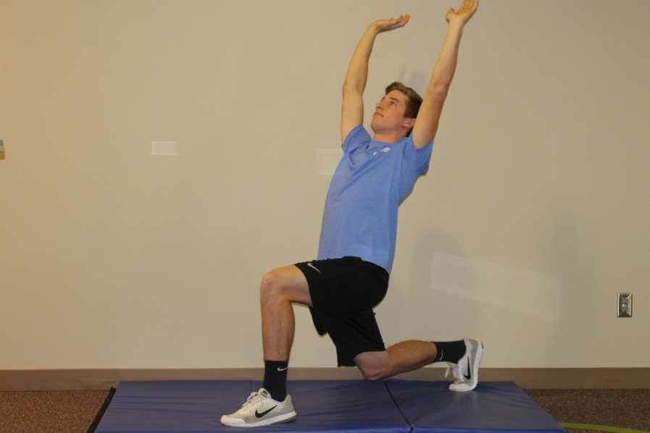
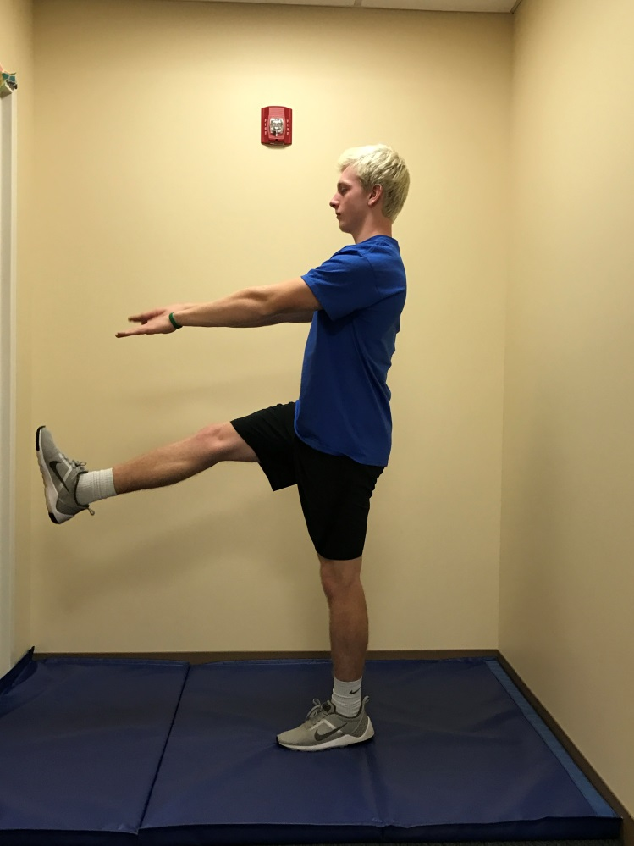
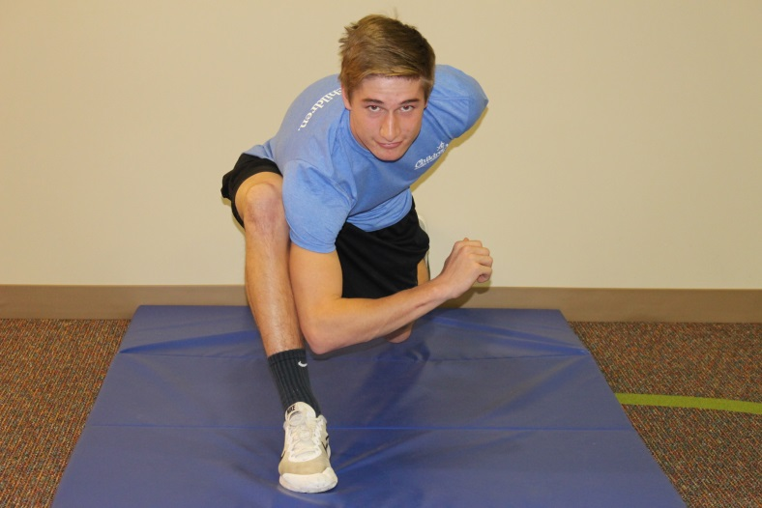
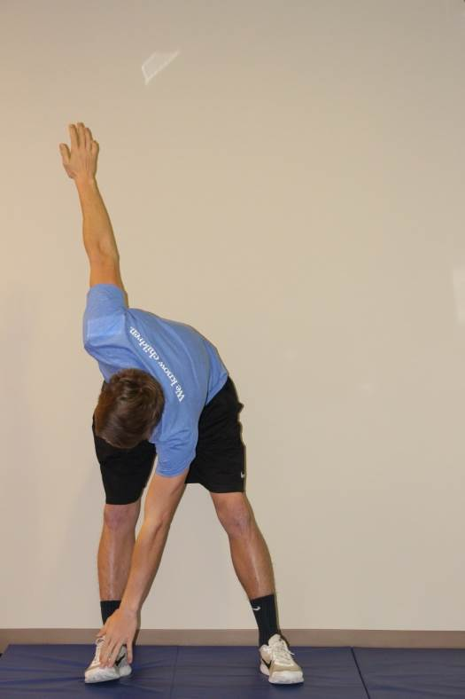

- Follow with practice swings to prepare the body for motion. Hit balls prior to round starting with wedge and working up to driver.
- After a round or away from the links, slow stretching of the hip flexors, hamstrings, calf, upper and lower back then shoulders will help with flexibility.
- Core strength is the key to the preparation for the golf swing. Front and side planks with movement and rotation are the most functional. Examples below:

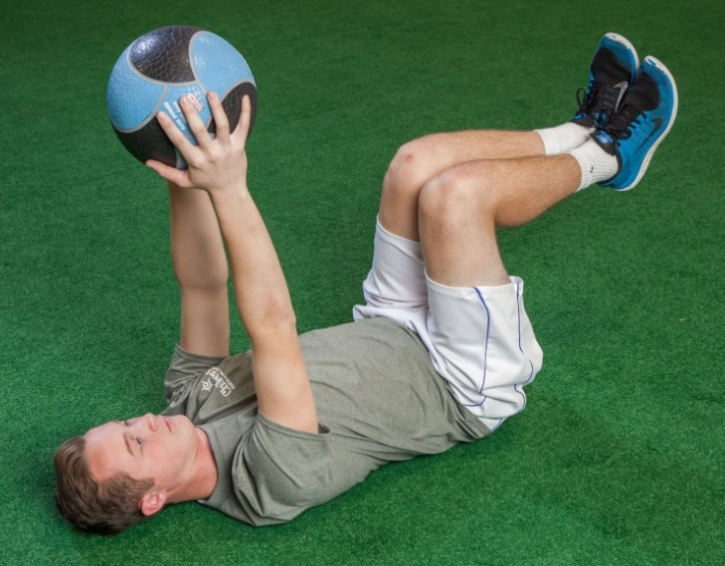
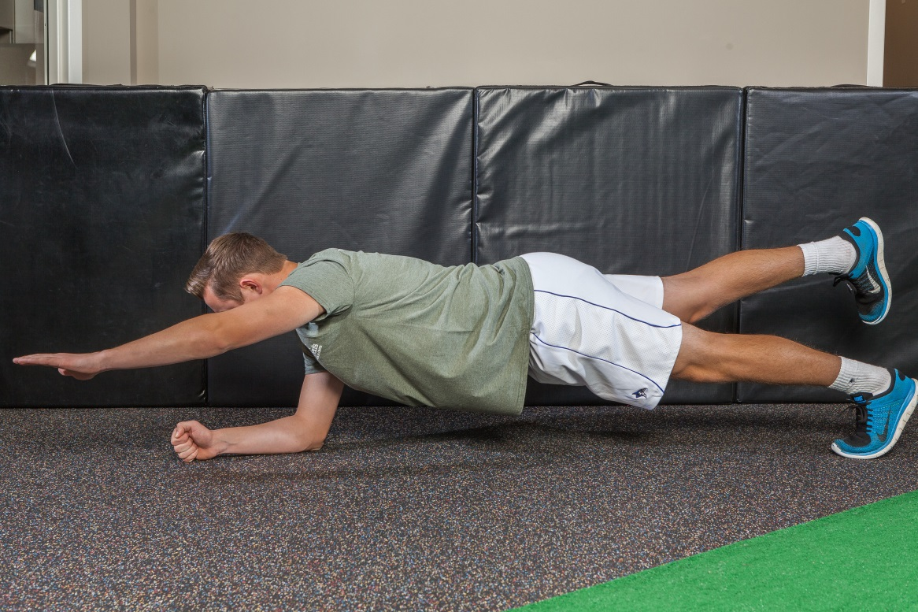

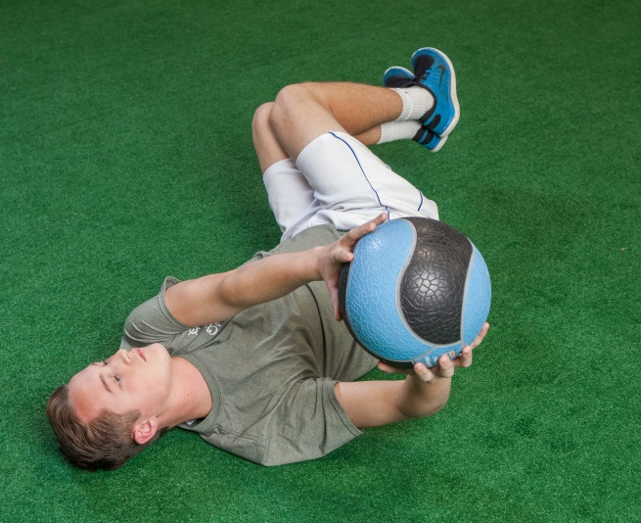
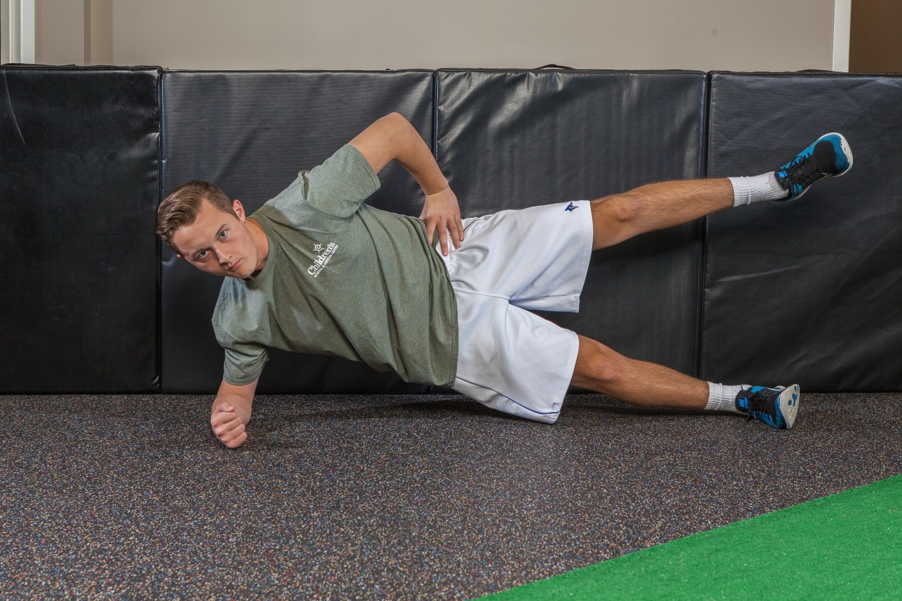

In golf and other sports, mastering new skills and trying to be perfect can lead to frustration and burnout. It’s been shown that about 70 percent of young athletes give up on youth sports by age 13. The key to keeping young players engaged and on the course, could be in letting kids play the game free from pressure. Teaching proper techniques is important, but keep the environment positive and fun. Emphasizing what’s fun about golf— not what’s frustrating—can make a golfer for life.

For more information visit:
American Medical Society for Sports Medicine www.sportsmedtoday.com/more-sports-injuries.php
American Orthopedic Society for Sports Medicine www.Stopsportsinjuries.org/STOP/STOP/Prevent_Injuries/Golf_Injury_Prevention.aspx

Consult your primary care physician for more serious injuries that do not respond to basic first aid. As an added resource, the staff at Children’s Sports Medicine is available to diagnose and treat sports-related injuries for youth and adolescent athletes. To make an appointment, call 402-955-PLAY (7529).

