Healthy Snack Choices for Youth Sports

Did You Know?

Team snacks are a great way to fuel up after a practice or game, and are an ideal opportunity to teach young athletes about good nutrition. Remember, the goal of the game should not be the snacks at the end!
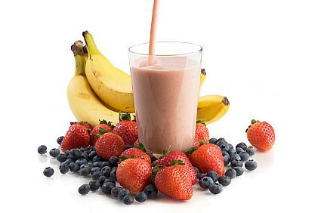
- Eating healthy helps prevent injuries and improve muscle development.
- Junk food is calorie rich, sugar loaded and nutrient poor — it provides no
nutritional value to the body.
- Soda is the #1 source of added sugar in children’s diets, followed closely by
fruit drinks. Many of these beverages do not provide nutrients that support
children’s growth and development.

Focus On These Points:

- Emphasize food as fuel: Your body needs quality fuel in the form of food to keep it running properly and maximize performance!
- Be a role model: Young athletes admire no one more than you; their parents, coaches, and other adults that influence their daily choices.
- It’s never too early: Start establishing habits in young athletes that will carry over as they get older and the intensity and demands of their activities continue to increase.
- Stick with water: It’s cheap, easy, and their growing bodies can always use it! Sports drinks should be used after 60 minutes of moderate physical activity.
- Get your young athlete involved: Have them help cut fruit and vegetables, organize cheese cubes in baggies, write/decorate their teammate’s names on paper bags, or even go to the store along with you!
- Empower them to make their own health decisions and help inspire their teammates!

- Quick Snack Ideas for Game Day!

- Fruit salad: Slice or buy pre-cut fruit salad. Bring a serving spoon and individuals bowls to serve to the athletes. For a fun twist, make fruit kabobs!
- Fun trail mix: Make a mixture of a dried fruits, nuts, seeds, pretzels, and one sweet.
- Apple slices & peanut butter: Cut or buy apple slices and individual packs of peanut butter or peanuts.
- Want more dipping options? Add whole grain crackers or crisp breads.
- Mini yogurt parfaits: Divide granola into individual snack baggies and serve with prepackaged individual yogurt cups and spoons. Add some berries for an extra boost of flavor and nutrients!
- Mini deli sandwiches: Whole wheat roll, 1 small slice cheese, and 1 piece of turkey Italian dressing.
- Veggies with dip or hummus: Divide pre-cut veggies into snack bags and bring individual containers of hummus dip. Kids love dipping!
- Cracker stackers: Same idea as mini deli sandwiches, but use
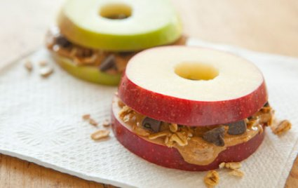
crackers

Young athletes with high activity levels, carbohydrates can become vital for
peak performance, as children are limited in their ability to store carbohydrates.
Carbohydrate | Protein
Fuel and Focus  Helps keep your muscles energized and brain focused on the game | Recover and Build  Aids in forming new tissue to help with proper growth, development, and exercise recovery
Fruit  Banana, apple, strawberries, grapes, melon, applesauce, orange slices | Nut butter  Peanut, almond, or soy nut for peanut-free teams
Vegetable  Cucumber slices, carrots, sugar snap peas, pepper slices | Lunch meat  Slices rolled up, or cubes on a kabob
100% fruit leather  Like a fruit roll-up, but healthier! | Nuts or seeds  Peanuts, almonds, cashews, sunflower, pumpkin
Dried fruit  Raisins, cranberries, cherries | Cheese  Cheese sticks, slices, cubes, squares
Whole grain crackers or pretzels  Look for the whole grain symbol on the front of the box | Hardboiled egg  Make a few dozen and keep them in a cooler during the game
Popcorn  Aim for a little salt; avoid the loaded butter or strong flavorings | Hummus  Most stores offer small pre-packaged containers for convenience
Granola bars  Watch those covered in chocolate or other sugary coatings | Yogurt  For extra hot days, freeze the yogurt for a cool treat after the game

For more information visit:

Academy of Nutrition and Dietetics www.eatright.org
US Olympic Committee Teamusa.org/About-the-USOC/Athlete-Development/Sport-Performance/Nutrition/Athlete-Factsheets-and-Resources

Consult your primary care physician for more serious injuries that do not respond to basic first aid. As an added resource, the staff at Children’s Sports Medicine is available to diagnose and treat sports-related injuries for youth and adolescent athletes. To make an appointment, call 402-955-PLAY (7529).

