How to Choose a Running Shoe

A foot is required to adapt to absorb the forces it experiences when it makes contact with the ground during walking and running. Generally, it does this by moving between pronation and supination as it makes contact with the ground and moves through a stride. However, depending on how the foot is built, it may need a little extra help with the process, which is where shoe type comes in. There are 3 different types of shoes, and each works best to minimize injuries when paired with the appropriate type of foot.

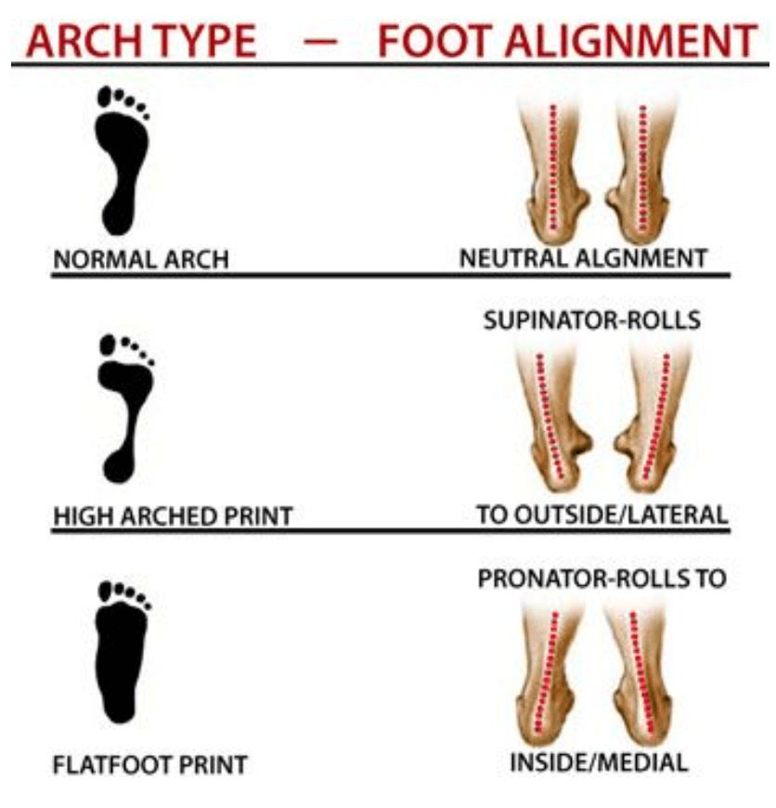
Foot Type
A foot generally falls into one of three categories.
The 3 categories are: pronated, supinated, and neutral.
- A pronated foot is one that is very flexible and rolls toward the inside. It has a very low arch when bearing weight, and if one were to get their foot wet and step on a piece of paper, it would have very little arch visible.
A pronated foot can absorb the forces experienced during the stride, but rather than dispersing them evenly across body structures, which is ideal, it will tend to focus them on the knees and inside of the lower legs and, which could lead to injury.
- A supinated foot is the opposite of a pronated foot. This foot has a very high arch, and tends to roll outward when bearing weight. It would have a very obvious arch on a wet footprint. This foot type is very rigid, and does not absorb forces well. Rather, it allows them to travel up into the lower legs and knees, which can lead to injury.
- A neutral foot is somewhere in between pronated and supinated. Generally, it does a good job of moving through the stride as intended, so it does a good job of absorbing the forces experienced and dispersing them evenly through the body. A wet footprint for this type of foot would have an arch, but it wouldn’t be excessive. Generally speaking, this type of foot may be the least prone to injury, but given the nature of running (numerous miles with the foot absorbing many pounds of force with each stride, often without much of a break) may still be injured.

Parts of the Shoe
Heel Counter: A rigid piece surrounding the heel that provides stability.
Upper: The part of the shoe that encloses the foot and includes the laces.
Toe Box: The area where the toes are located.
Midsole: The portion between the outer-sole and upper that is responsible for most of the shoe’s shock absorption.
Outer-sole: The outer layer of the bottom of the shoe where the treads are.
Each part of the running shoe has a specific purpose.

Shoe Type
There are several shoe types that help support the different foot types.
- The first is a motion control shoe. This shoe type features a firmer midsole, which helps to control the excessive motion that an over pronated foot experiences. This shoe should be reserved for athletes with extreme pronation. Motion control shoes are typically fairly rigid through the midsole, to help counter the increased flexibility of the foot.
- The second shoe type is a stability shoe. This shoe type is intended for people who have a mild amount of pronation, while motion control shoes are intended for people with excessive pronation, or over pronation. Stability shoes offer a firm area in the midsole to help support the arch, but are more flexible and cushioned than motion control shoes.
- The last shoe type is a neutral shoe. This shoe is designed for people with neutral arches. This shoe also works well for people who supinate. It features a good mix of cushioning and support, and tends to be fairly flexible.
General Considerations
There are several other things to consider when it comes to choosing a running shoe.
- It is always better to buy a shoe from a good athletic shoe store, or even a specialized running shoe store. This way, the different options can be tried on, so the athlete is able to identify which pair feels the best to them. At most stores of this nature, the sales people are trained to help identify the type of foot and know which shoes work well with which feet. They may even allow an athlete to jog back and forth on the sidewalk outside the store so they can get a good feel of the shoes.
- It is also a good idea to bring anything you may wear along with the shoes with you to the store to try them on together. This includes orthotics, ankle braces, special socks, etc. This practice will help ensure the shoes are still comfortable once they are home and being worn in a more real-life situation.
- Generally speaking, it is better to go try on shoes at the end of the day, rather than the beginning, as feet tend to swell a bit over time. This ensures they will still fit well even if the run happens to land at the end of the day rather than the beginning.
- It is a good idea to keep at least a general idea of how many miles have been run in a pair of shoes. This is because shoes need to be replaced every 300-500 miles, or at least once each athletic season. Failure to do so can result in injury. A good way to do this is to write the date purchased directly on the shoe. If it is possible to calculate an average number of miles run weekly, this date can be used to calculate the approximate number of miles on the shoes. Another way to tell if shoes need replaced is to pay attention to aches and pains. If things are starting to hurt where then didn’t before, it is worth evaluating how old the shoes are.
While following these guidelines may help decrease injuries, it is important to understand that even if you are following these guidelines, injury may occur. Don’t let pain become an injury. It is always better to speak to a doctor earlier than later, as the types of injuries experienced with distance running tend to be of the overuse variety, and are much easier to take care of the earlier they are reported.

Finally, please understand that these are simply guidelines. It is generally a good idea to try to stick to these categories, but all feet are different, and may not fit perfectly into one category or another. It is important to always base the final decision on the way the shoes feel, rather than what seems like it should logically work.

Consult your primary care physician for more serious injuries that do not respond to basic first aid. As an added resource, the staff at Children’s Sports Medicine is available to diagnose and treat sports-related injuries for youth and adolescent athletes. To make an appointment, call 402-955-PLAY (7529).

