HYDRATION FOR SPORT

Dehydration & its Consequences

Water accounts for approximately 73% of the human body. Maintaining this level of water in the body is critically important for normal physiological functions. During physical activity in the heat, the body sweats. Sweat then evaporates and cools the body. We must drink water to continuously replace what is lost in sweat. If the body is unable to adequately evaporate sweat from the surface of the skin, the core temperature will begin to rise rapidly. Dehydration occurs when the body’s fluid in sweat loss exceeds fluid intake. Dehydration of 1-2% of the athlete’s body weight begins to have a negative effect on physiologic function and athletic performance. If dehydration level exceeds 3% of the athlete’s body weight, the athlete is at risk for an increased disturbance of physiologic function and thus increases the risk of heat illness. Dehydration is preventable if proper hydration guidelines are followed.
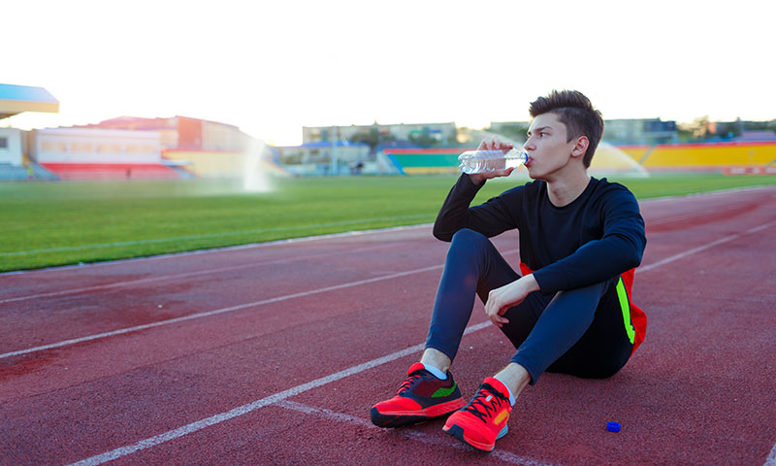
Signs and Symptoms of Dehydration

- Chills and dizziness
- Dark colored urine
- Headaches
- Dry mouth or thirst
- Overall weakness.

Signs and Symptoms of Heat Illness

If dehydration progresses or is prolonged, the risk of a heat illness rises. Severe incidences can become fatal. These symptoms include:
- Increased heart rate and body temperature
- Difficulty breathing
- Muscle cramps and/or tingling in arms/legs.
- Nausea

Preventing Dehydration and Heat Illness

- Properly acclimatizing your body to the heat
- Make sure you are preparing for the demands of your sport at least several weeks in advance so your system is prepared and ready!
- Remember it’s better to “train your body for practice rather than use practice to train your body”
- Fluid replacement before, during, and after exercise
- Appropriate clothing to keep your body cool- light colored, loose fitting, one layer, breathable
- Early recognition of dehydration and heat illness
- Monitor the intensity of physical activity appropriate for the athlete’s fitness level and acclimatization status.
Suggested Guidelines for Fluid Replacement and Energy
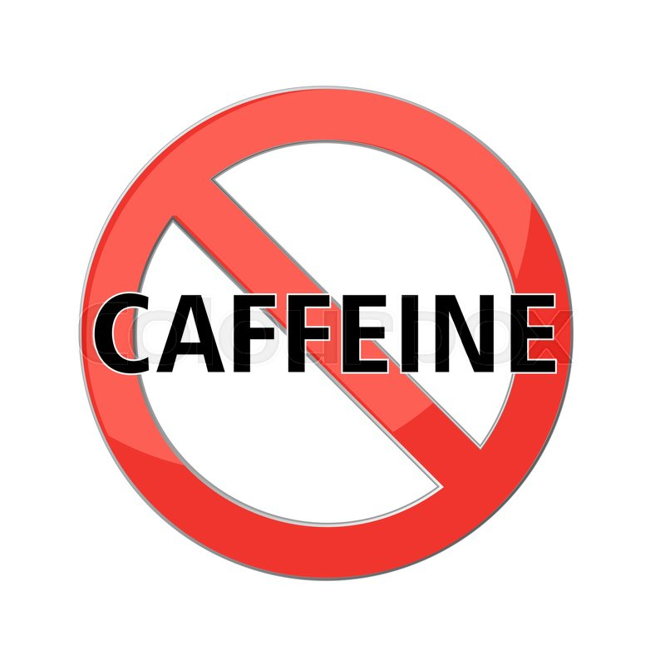

- Avoid caffeinated beverages as this can increase fluid loss.
- Pre-competition meals should be eaten 1 to 4 hours prior to the athletic event and
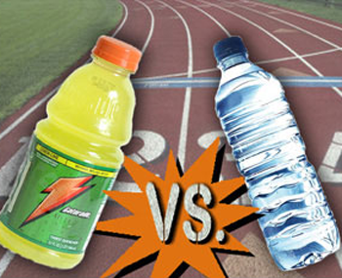
include foods with high carbohydrates and water content
- The only “fuel” that should be consumed right before competition is cool fluids
- Include high-water content foods in your child’s daily diet
  - i.e. oranges, lettuce, tomato, cucumbers, watermelon
- Before the event: Drink approx. 20 oz. of cool water 2-3 hours before the start
- Immediately prior: Drink another 10 oz. of fluid water 10-20 minutes before that start
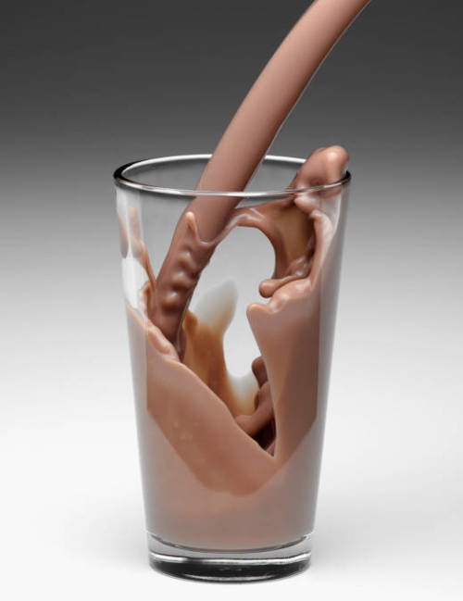
- During: Drink 4-6 oz. of cool water, diluted sports drink/fruit juice every 10-15 minutes
during the event
- After the event: weigh your child and replace every pound of weight lost with 16 oz. of
plain water or diluted sports drink. Chocolate milk is also a good fluid and energy
replacement drink at this time!

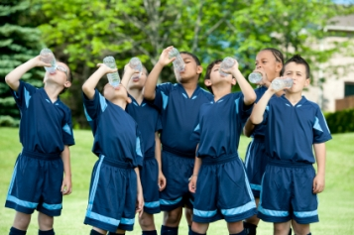

For more information visit:

National Athletic Trainers Association (NATA) www.NATA.org
American College of Sports Medicine (ACSM) www.ACSM.org
Korey Stringer Institute (KSI) www.ksi.uconn.edu

Consult your primary care physician for more serious injuries that do not respond to basic first aid. As an added resource, the staff at Children’s Sports Medicine is available to diagnose and treat sports-related injuries for youth and adolescent athletes. To make an appointment, call 402-955-PLAY (7529).

