**THE DO’S AND DON’TS OF CAST AND SPLINT CARE**

Splints and casts are used to provide protection of bones and soft tissue after an injury or surgery occurs. Splints can be custom-made or an “off the shelf” variety with Velcro straps. Casts are made to fit and immobilize the affected area in a specific position to optimize the healing process. A cast and custom-made splint can be made from plaster and/or fiberglass depending on your doctor’s preference. Cotton or synthetic padding inside the cast provides protection and comfort while the cast is in place.

There are several cast and splint care instructions that need to be followed carefully for the cast or splint to be effective. It is also important to follow these instructions to prevent the injury from getting worse and prevent other injuries from occurring.

**DO**

* Keep the cast or splint must clean and dry. Moisture in the cast can cause skin irritations and a change in the position of the cast padding.
* Protect the cast with plastic bags when bathing and elevate it out and away from the water. Commercially made cast covers are also available and can be purchased from various venders.
* Be extra cautious and treat every bag and cast cover like it may have a hole in it! If the edges become damp, you may use a hairdryer on the cool setting to help dry the cast or splint.
* Protect the cast from sand, dirt, gravel, etc. *Sand, dirt, gravel, etc. can cause pressure sores. If you have a wound underneath the cast it could also cause an infection. It is helpful to keep leg casts covered with a sock or slipper.*
* Rough edges can be gently filed smooth with a fingernail file or covered with moleskin, which is available at most pharmacies.
* Use a cast shoe when in a walking leg cast, to help avoid rapid deterioration of the cast.
* Contact your doctor if the cast develops soft spots or cracks or it it becomes very wet. The cast may need to be replaced.

**DON’T**

* Scratch the skin under the cast by placing objects inside of it.
* Stick objects in the cast or splint as this may cause skin abrasions and a change in the position of the padding. Objects that become stuck in the cast can cause a pressure sore. If this occurs, contact your doctor. The cast may need to be replaced.

[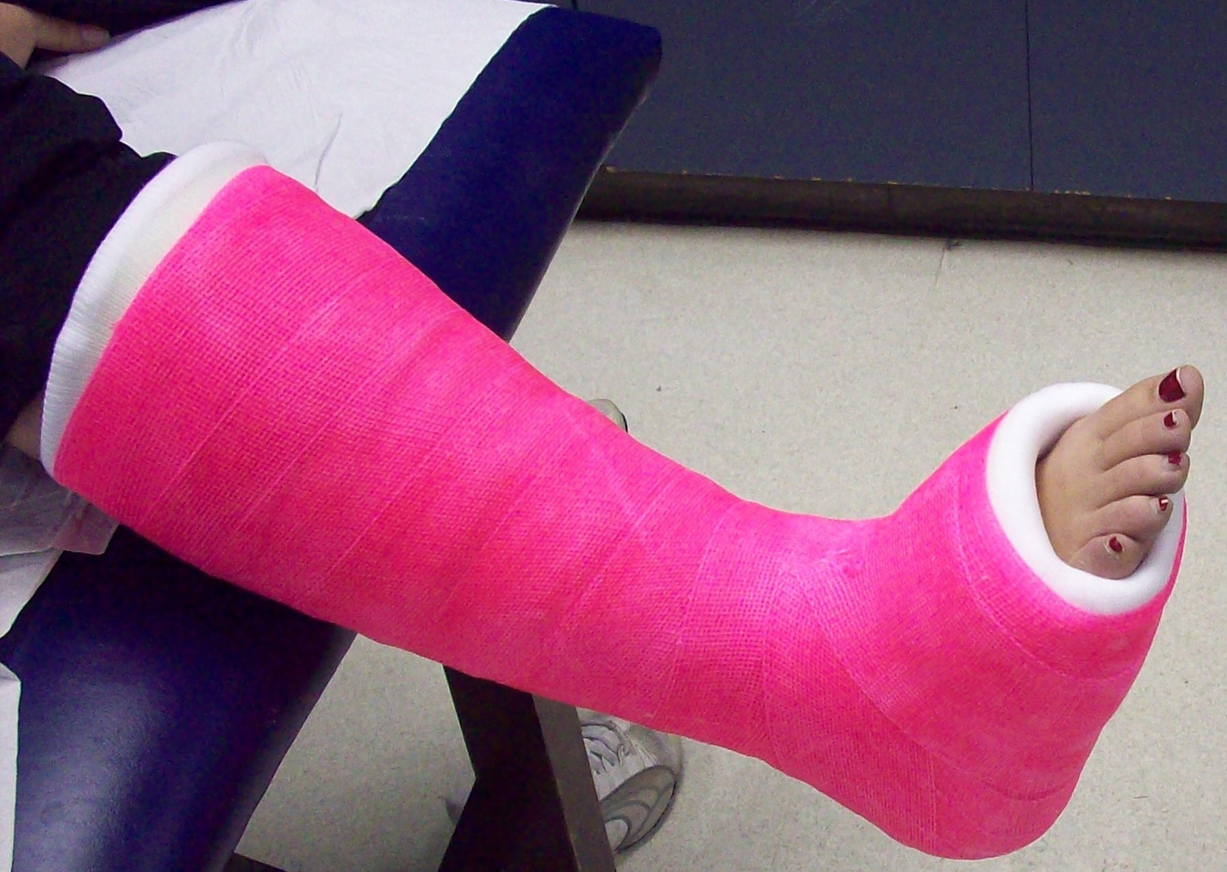](https://www.google.com/url?sa=i&rct=j&q=&esrc=s&source=images&cd=&cad=rja&uact=8&ved=2ahUKEwjK4bGqxOvfAhWwo4MKHZJ4A1QQjRx6BAgBEAU&url=https://www.topsimages.com/images/tip-toe-walking-casting-legs-7e.html&psig=AOvVaw03ml4ptR9wyvmml-hHBhed&ust=1547495557191592)

* Remove any padding or lining from the cast or splint. The padding and

lining is there to keep the cast or splint comfortable. It is also there to

protect you during cast removal.

* Do not use any powders, lotions, or oils inside of the cast. They may

irritate the skin.

* Do not attempt to remove any part of the cast
* Do not use your cast as a weapon. *Casts and splints are heavy and could*

*cause harm to someone else. It could also cause your injury to become worse.*

**Swelling**

Swelling, especially in the fingers, is common within the first few days after a cast or splint has been applied. To relieve the swelling, elevate the extremity above the level of the heart. Encourage children to move their fingers or toes frequently to help reduce the swelling and prevent stiffness. If excessive swelling is causing severe pain, numbness, tingling, burning, or pressure areas on the skin to contact your doctor immediately.

**Itching**

The skin under the cast may become itchy but do not place anything inside of the cast. You may use a hairdryer on the cool setting to blow cool air into the cast to help alleviate any itching. Other methods include over the counter anti-histamines or letting a fan blow into the cast or splint. Keeping the cast cool is the best way to prevent it from becoming itchy.

[](http://www.google.com/url?sa=i&rct=j&q=&esrc=s&source=images&cd=&cad=rja&uact=8&ved=0ahUKEwjo7cizs7HWAhUL7YMKHYxrABMQjRwIBw&url=http://www.scarymommy.com/kid-who-refuses-to-participate/&psig=AFQjCNGQMSa-GVSYTcF6HCH6yC7LKpcDzA&ust=1505915713006242)

**Activity**

Your doctor will provide you with instructions on allowed activities and

restrictions while the cast is in place, including weight bearing status in the

cast or splint. In general, children should not participate in any sports, PE

class, recess, and other activities that involve wheeled and motorized

equipment. These activity restrictions help prevent further injury to your

child and other children, and protect the cast or splint.

**When to contact your doctor:**

* Increasing pain that is not relieved by elevation, rest, and pain medication prescribed by your doctor.
* Numbness, tingling, or burning that is persistent and not relieved by elevation and rest.
* Areas of persistent pain or pressure caused by the cast.
* Loss of feeling or movement in your fingers or toes.
* Drainage from your cast after surgery.

**Waterproof Casts**

Depending upon the location, type, and severity of your fracture your provider may choose to place you in a waterproof cast. The waterproof cast is applied with a synthetic water-repellent padding instead of cotton. This is designed so that you are able to get your cast wet, if your physician allows. Although you are able to get your cast wet, there are still rules to follow when it comes to getting



your cast wet.

* After your cast gets wet it is important to drain all of the water out of the cast
* Allow the cast to be dry for 24 hours between times of getting it wet
* Do not swim in natural bodies of water (lakes, rivers, oceans, etc.)
* Rinse the cast thoroughly with clean water after swimming, showering, or

bathing

* For your safety when swimming, deep water should be avoided.
* In addition to the rules about getting your cast wet, you must still follow the general cast care instructions listed above. It is also important to contact your doctor if you experience any of the concerns listed above or if you experience maceration (i.e. softened, white, or wrinkled skin), skin irritation, pain, or your cast does not dry out.