CRUTCH WALKING INSTRUCTIONS

Safety TIPS:

- Secure the arm pads and hand grips prior to use.
- Tighten all hardware (screws and wing nuts) at least once per week.
- Clean the crutch tips of pebbles and dirt to minimize slipping.
- Have someone assist you until you master the technique of crutch use.
- Remove loose rugs and electrical cords from all potential paths to avoid tripping and falling.
- Replace crutch tips if they should wear out.
- Be careful on wet indoor surfaces which may be extremely slick.
- When standing on crutches, place them a short distance in front of your feet and lean forward slightly.
- Never stand with the crutches even with your body, as you can lose your balance either forward or backward in this position.
- Keep body weight on your wrists/hands, never your underarms.
- It helps to have a buddy walk with you during the day, to open doors and help carry your school supplies.
- Always wear backpack on BOTH shoulders.
- Always wear shoes – never slippers or flip flops as they will affect your balance.

To walk with Crutches:

- Put your crutches under your arms and press them against your body.
- Bear your weight on your hands, not under your arms.
- Place the crutches ahead of you approximately 12 inches.
- Push down on the grips as you step slightly past the crutches, leading with the GOOD LEG.
- Advance the crutches forward approximately 12 inches; then continue.
- Move slowly at first until a natural pattern is achieved.
- It’s important to use crutches correctly. If any numbness or tingling is felt in your armpits or upper arms, ensure you are using proper technique as demonstrated in clinic.

To sit down:
- Stand with chair 2-3 inches behind legs.
- Put both crutches in your hand on the
affected side, reach backwards for the
chair or seat with the other hand.
- Lower yourself slowly into the chair,
bending at the hips.

To get up from a seated position:
- Reverse this process
- Hold both crutches on affected side.
- Slide to the edge of the chair or seat.
- Push down on the arm of the chair on
the good side.
- Stand up, and then put the crutches
under your arms.
- Press the arm pads into the body.
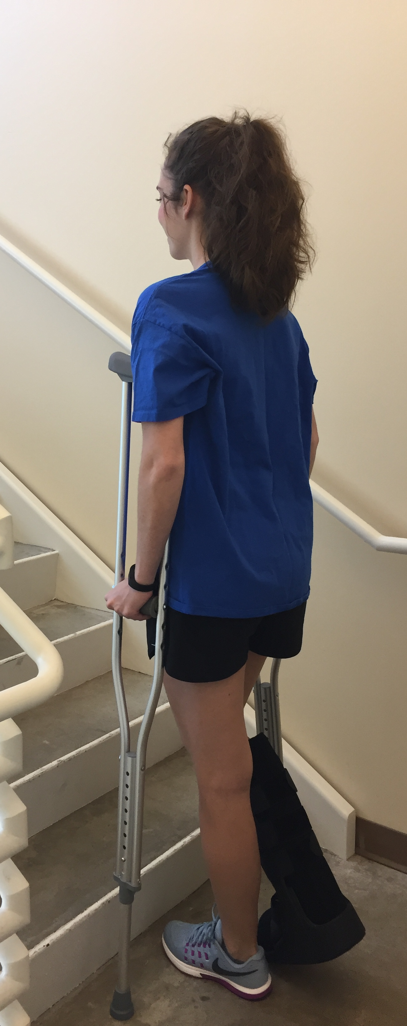

To go upstairs:
- Start close to the bottom step, and push down on the
crutches with your hands.
- Step up first with the “good” foot, then the injured
leg followed by the crutches.
- Take one step at a time.
- Have someone walk behind you to provide support (or use
elevator)

To go down stairs:
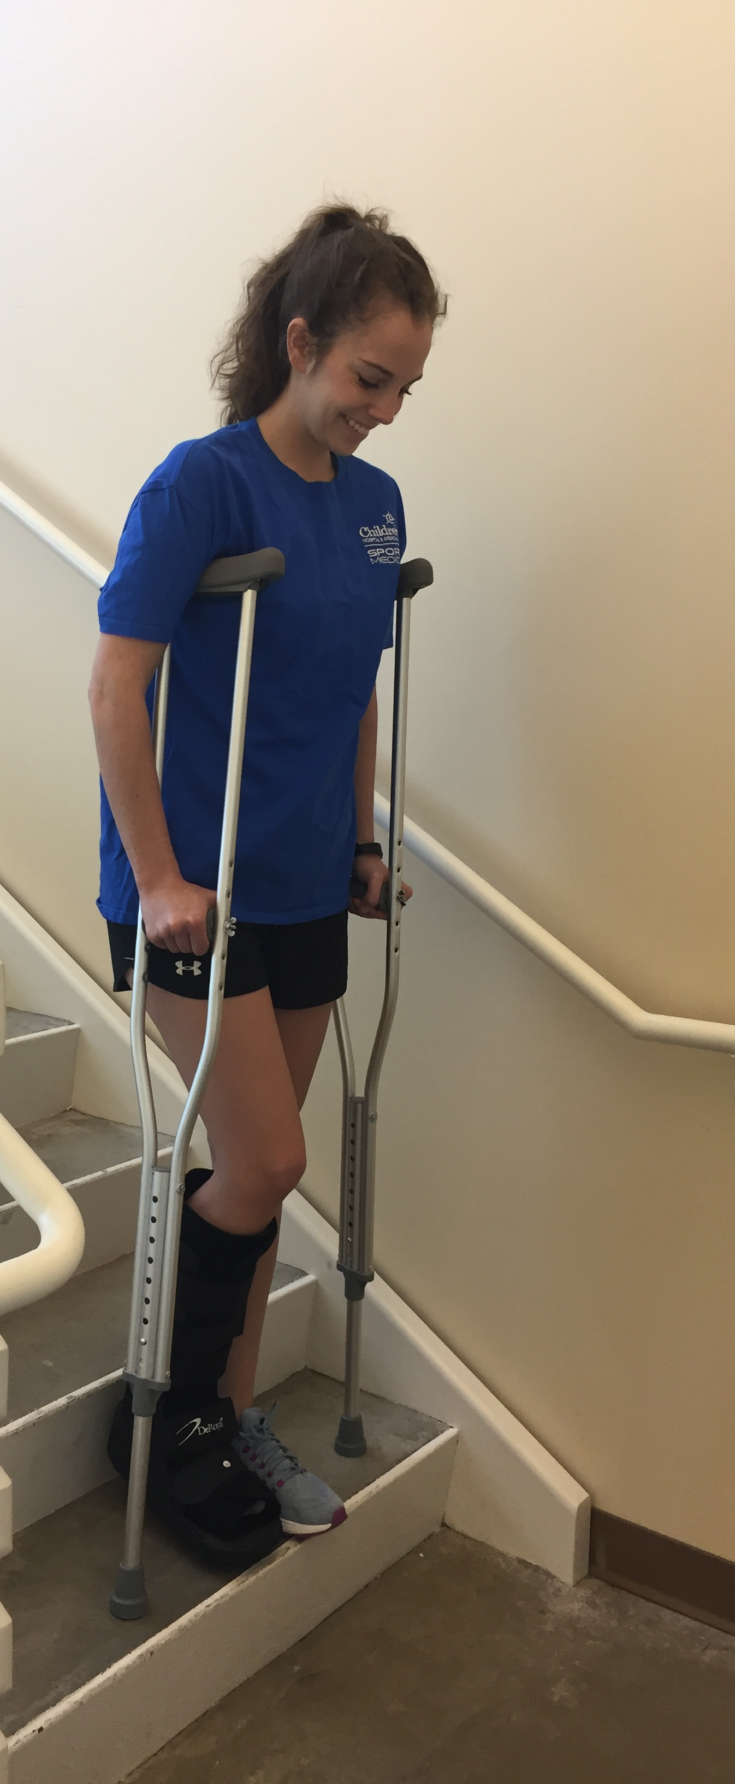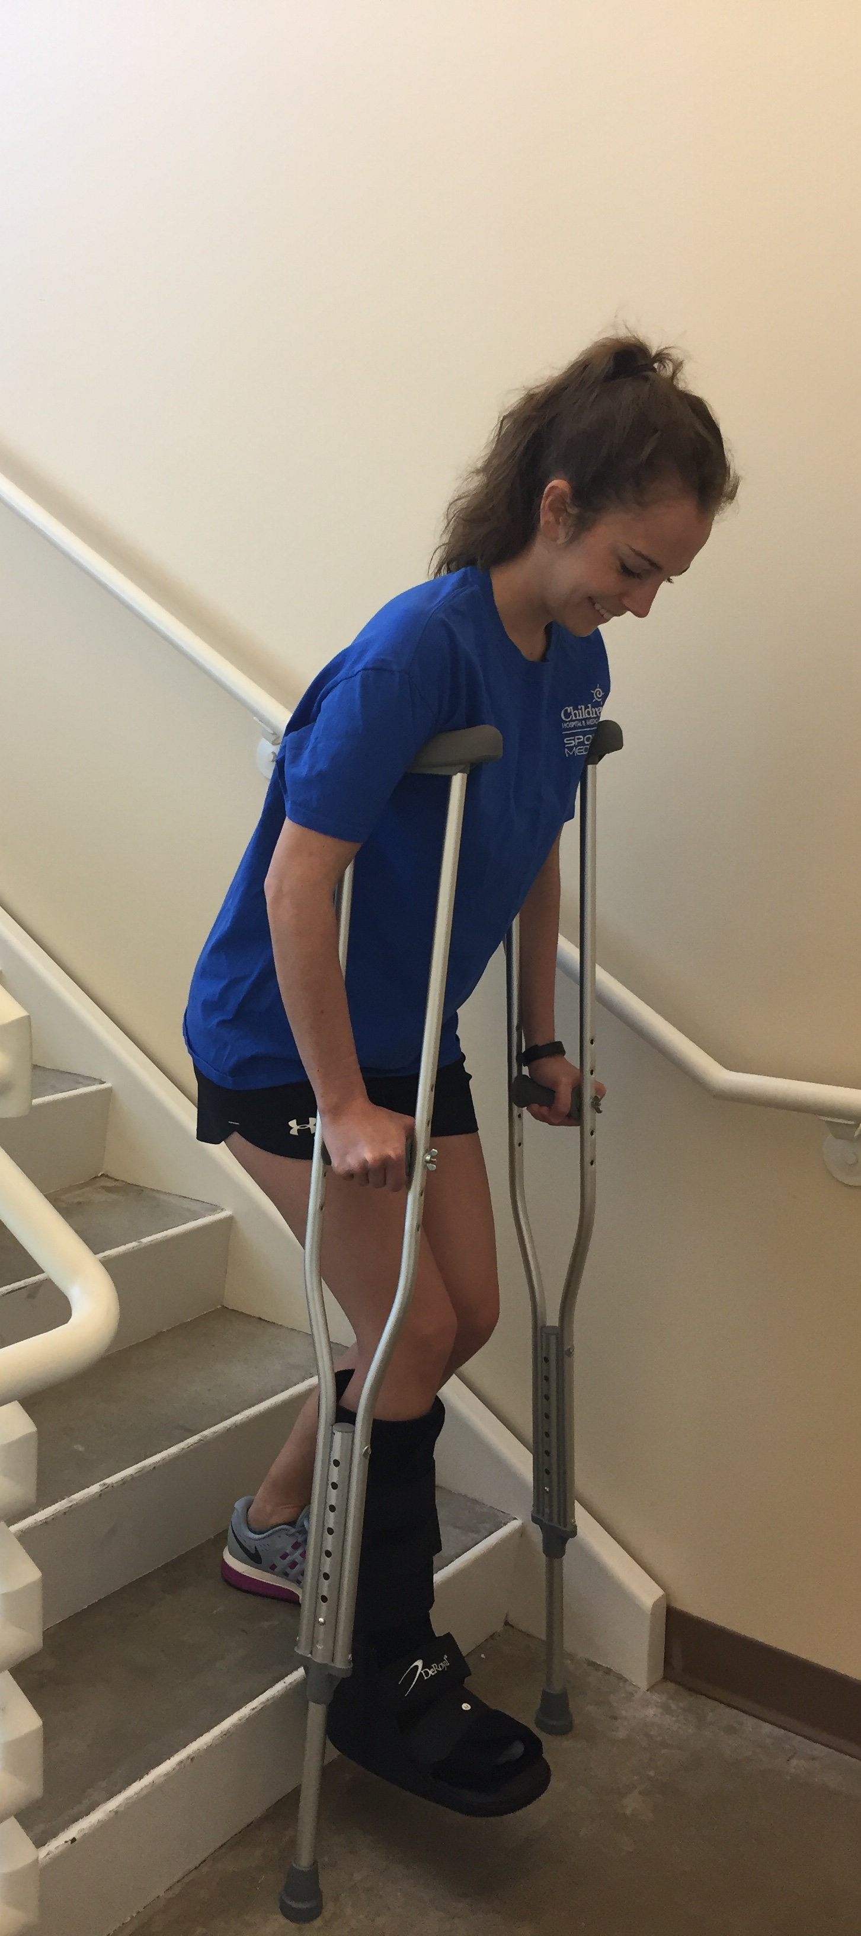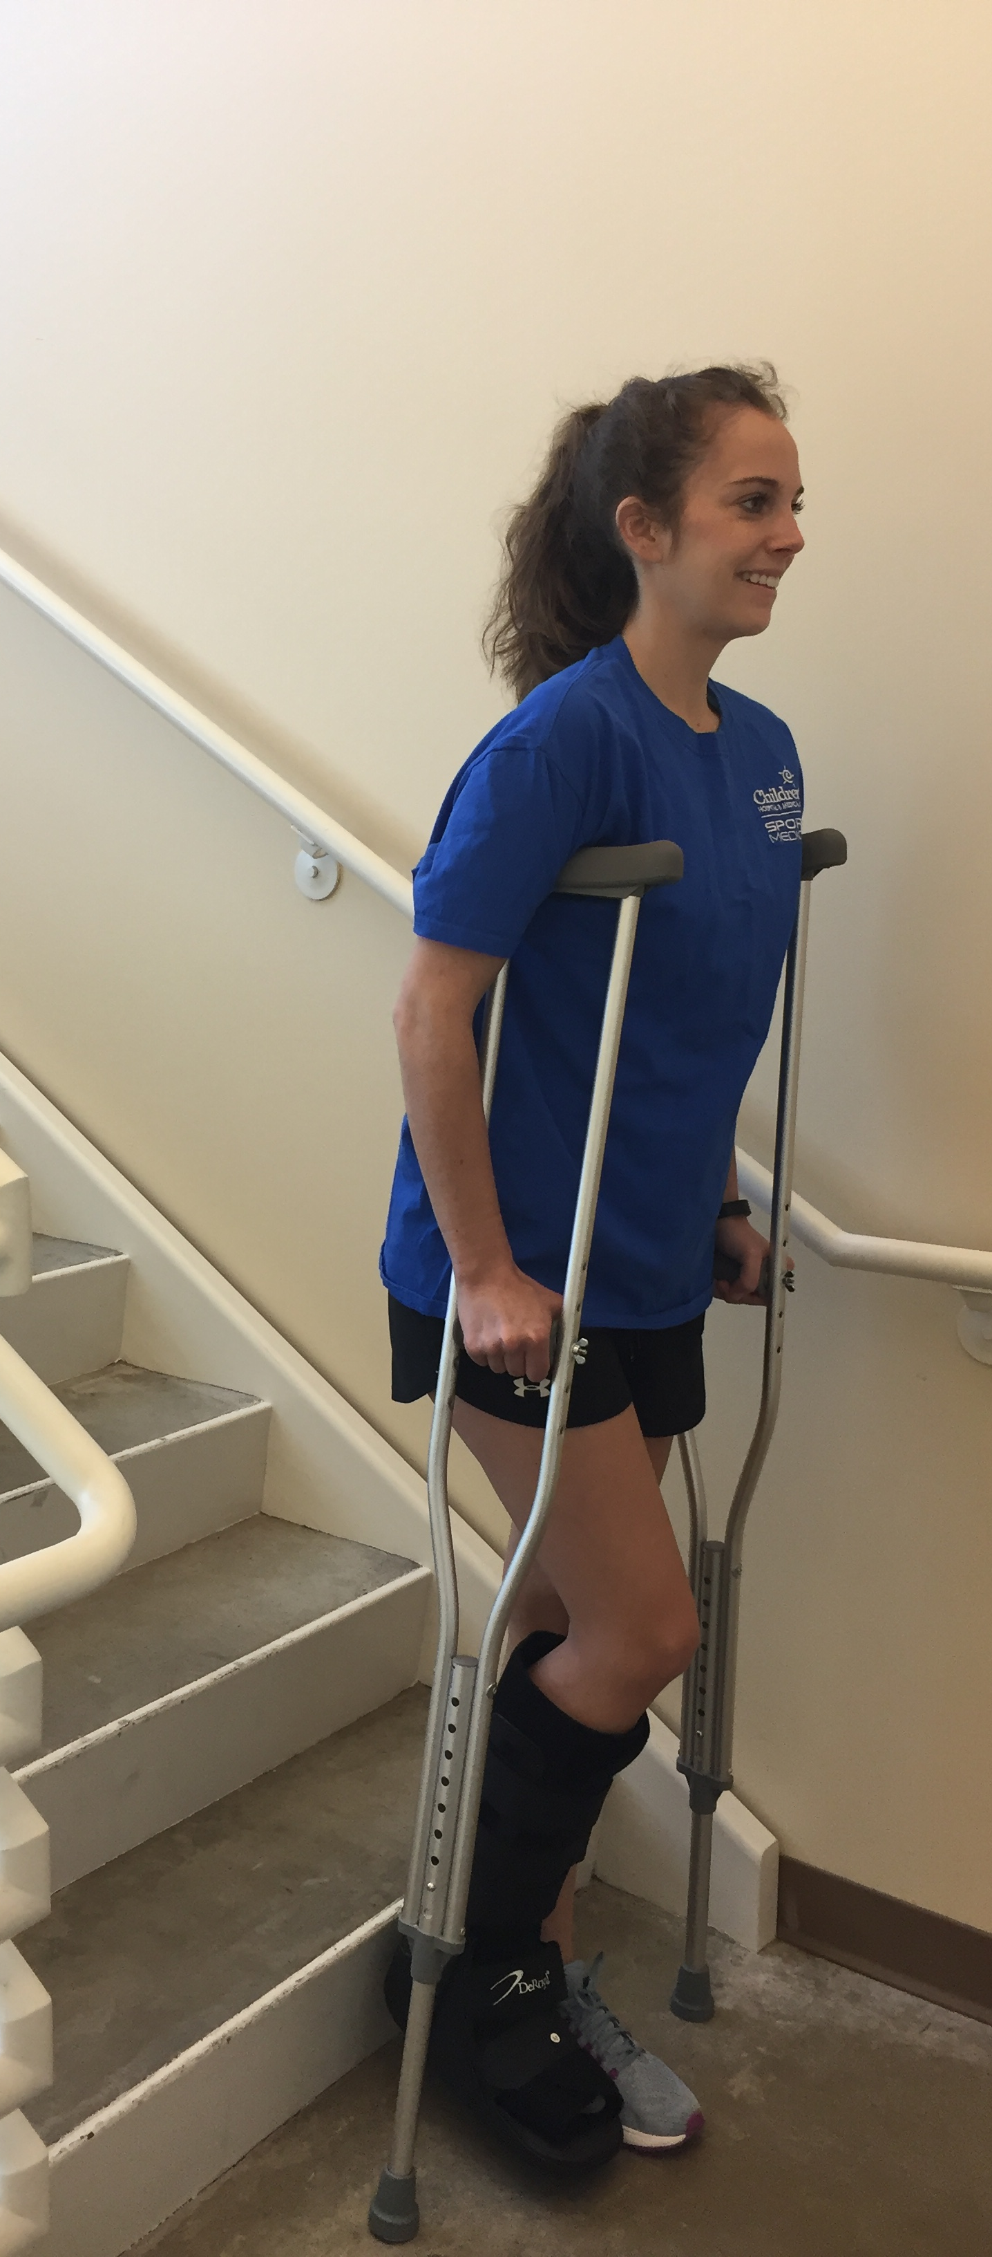
- Start at the edge of the step, keeping your hips beneath
your body.
- Place the crutches on the step below, followed by
the “bad” leg, then the “good” leg.
- Be sure to bend at the hips and knees to prevent leaning
too far forward, which could cause you to fall.
- If a handrail is available, place both crutches in hand on
unaffected side with rail on affected side. Advance hand
on rail slightly and place crutches on lower stair.
- Take one step at a time.
- Have someone in front of you to provide support

REMEMBER:
- UP with the GOOD first, DOWN with the BAD first! Crutches are ALWAYS DOWN FIRST!
- Use the crutches as prescribed by the physician and do not attempt to bear weight on injured leg until told to do so.

