Overuse Injuries are the MOST Common Sports Injuries

​​ Over the past 20 years more children are participating in organized and recreational sports. With so many young athletes playing, it's no wonder bone, muscle and joint injuries are common. Acute sprains, strains and contusions are injuries that can occur from direct physical contact. However overuse injuries tend to develop overtime, are more subtle to recognize and often stem from increases in physical activity load and/or improper mechanics. Many of these can be prevented with proper training and stretching. However, once an injury occurs, early intervention is key for optimal recovery and reduced time away from sport. Examples of overuse injuries include: jumpers knee, achilles tendinitis, shin splints, stress fractures
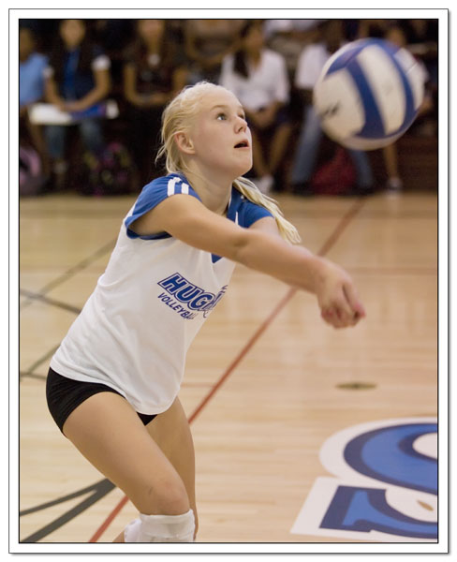
Why do they occur?
When physical stress is placed on the body, a process of internal
remodeling occurs. This remodeling process involves the breakdown
and subsequent buildup of our muscles, tendons, bones, etc.
Ideally there is a balance between the two, however if the breakdown
occurs more rapidly than any buildup, an overuse injury can result.

The progression of symptoms of an overuse injury follows a relatively
sequential course and is described in 4 stages:
- Pain in the affected area after physical activity
- Pain during physical activity, not restricting performance
- Pain during physical activity, restricting performance
- Chronic, persistent pain, even at rest

It can be confusing to determine if the pain the young athlete is experiencing is from an injury or part of the physical toll of practice and play. Consider the progression of their complaints and if the pain does not improve quickly and without residual compensation, than this is most likely due to an overuse injury.

What is the cause?
Most commonly these type of injuries can be directly related to training errors. These errors involve rapid acceleration of the intensity, duration, or frequency of activity. Overuse injuries also happen in people who are returning to a sport or activity after injury and try to make up for lost time by pushing themselves to achieve the level of participation they were at before injury. Proper technique is critical in avoiding overuse injuries, as slight changes in form may be the culprit. For this reason, coaches, athletic trainers, and teachers can play a role in preventing recurrent overuse injuries
How are they diagnosed?
The diagnosis can usually be made after a thorough history and physical examination. This is best done by a sports medicine specialist with specific interest and knowledge of your sport or activity. In some cases, x-rays are needed and occasionally additional tests like a bone scan or MRI are required as well. If you think your child has an overuse injury, talk with your doctor or a sports medicine professional.

How to treat overuse injuries:
Some tips for treating an overuse injury include:
- Cutting back the intensity, duration, and frequency of an activity
- Adopting a hard/easy workout schedule and cross training with other activities to maintain fitness levels
- Using ice after an activity for minor aches and pain
- If symptoms persist, a sports medicine specialist will be able to create a more detailed treatment plan for your specific condition.

How to prevent overuse injuries:
Most overuse injuries can be prevented with proper training and common sense:
- Learn to listen to your body and remember that "no pain, no gain" DOES NOT apply here.
- Be sure you are in good physical condition at the start of the season. If you are out of shape at the start of the season, gradually increase your activity level and slowly build back up to a higher fitness level
- Proper Warm Up:
  - Cold muscles are more prone to injury – so start with a dynamic warm up that includes 3-5 minutes of cardio followed by drills that get your joints moving in the directions needed for the upcoming physical activity
  - Now the warm muscles are prepared to stretch, holding each one for 30 sec.
- Proper Cool Down:
  - Stretching at the end of practice is too often neglected because of busy schedules. Post exercise stretching can help reduce muscle soreness and keep muscles long and flexible. Be sure to stretch after each training practice to reduce your risk for injury. For soccer, concentrate on the hips, thighs and lower legs.
- Limit the number of teams in which your child is playing in one season. Kids who play on more than one team are especially at risk for overuse injuries. Allowing your child to play one sport year round can also increase the risk of overuse injuries. Taking regular breaks and playing other sports is essential to skill development and injury prevention.

Because many young athletes are focusing on just one sport and are training year-round, doctors are seeing an increase in overuse injuries. Children's Hospital & Medical Center’s Sports Medicine Program has partnered with the American Orthopaedic Society for Sports Medicine’s STOP Sports Injuries to help educate parents, coaches, and athletes about how to prevent overuse injuries. For more information go to www.childrensomaha.org/sportsmedicine or www.STOPSportsInjuries.org.

