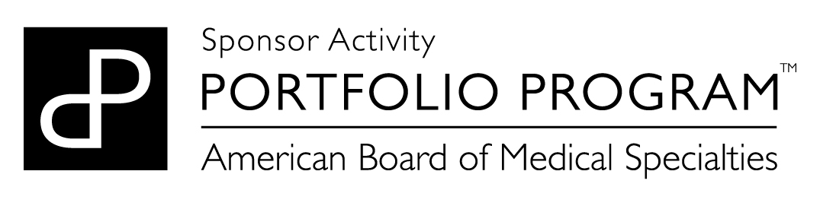
QI Notification for ABMS Multi-Specialty Portfolio Program (Portfolio Program ^{TM)} MOC Credit

1. Name of MOC Requestor:
2. Email:
3. Phone number:
4. QI Project Title:
5. Start date of QI Project:
6. Anticipated end date of QI Project
7. Are you the project leader?
☐Yes
☐No (please fill in information for the leader below)
Project Leader Name:
Project Leader Email Address:
Project Leader Phone Number:

8. Select up to 5 relevant topics for this quality improvement effort:

Access to care
Asthma
Burnout/clinician wellbeing
Cancer
Cardiovascular
Career Sustainability
Choosing Wisely/High Value Care/ Cost of care
CLABSI
Communication (patient-clinician)
Compliance (regulatory)
Diabetes
Documentation
Efficiency/ timeliness of care
Hand hygiene
Health Literacy
HIV
Hypertension
Immunizations/vaccinations
Length of stay
Medical home
Obesity
Opioid Use
Patient Centered Care
Patient safety/harm reduction
Prescriptions
Preventive care
Procedural Skills
Professionalism
Provider Resilience
Readmissions
Resource stewardship/utilization/ value /cost of care
Satisfaction
Sepsis
Surgical site infections
Teamwork/ team-based care
Transitions of care

9. Select one or more medical specialties addressed as part of this quality improvement effort:
American Board of Anesthesiology
American Board of Dermatology
American Board of Emergency Medicine
American Board of Family Medicine
American Board of Internal Medicine
American Board of Medical Genetics/and Genomics
American Board of Obstetrics and Gynecology
American Board of Ophthalmology
American Board of Orthopaedic Surgery
American Board of Otolaryngology
American Board of Pathology
American Board of Pediatrics
American Board of Physical Medicine and Rehabilitation
American Board of Plastic Surgery
American Board of Preventive Medicine
American Board of Psychiatry and Neurology
American Board of Radiology
American Board of Surgery
American Board of Thoracic Surgery
American Board of Urology
National Commission on Certification of Physician Assistants

10. How is the quality improvement effort funded?

Grant
Internal
Industry (Pharma or Medical Device manufacturer) funding
Subscription
Other

11. Select the methodology that most closely represents the methodology being used in this quality improvement effort:
A3
Continuous Quality Improvement (CQI)
IHI Collaborative Model
LEAN
Model for Improvement (PDSA/PDCA)
Six Sigma (DMAIC)
Total Quality Management (TQM)
Other

12. Project AIM Statement (An aim statement should state a clear, quantified goal set within a specific time frame. It states what you tried to change, a specific target population, by how much, and by when.):

13. Describe the types of interventions and tools that are being, will, or were used by participants in the QI Effort and describe how each is expected to impact individual practice and patient care, if known.
Intervention/Tool Type and Description (Multiple tools may or can be used)
How will this impact individual practice?
How will this impact patient care?

If you have any questions when completing this form please email MOC@childrensomaha.org

