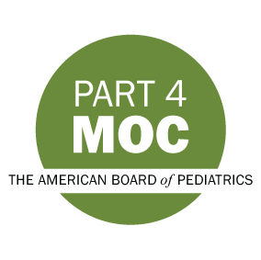
QI Notification for ABP MOC Credit
1. Name of MOC Requestor:
2. Email:
3. Phone number:
4. QI Project Title:
5. Start date of QI Project:
6. Anticipated end date of QI Project
7. Are you the project leader?
☐Yes
☐No (please fill in information for the leader below)
Project Leader Name:
Project Leader Email Address:
Project Leader Phone Number:
8. Project AIM Statement ( An aim statement should state a clear, quantified goal set within a specific time frame. It states what you tried to change, by how much, and by when.):

9. How many months does the project expect a physician to be actively involved in order to receive MOC Part 4 credit? (Please note: The ABP looks to Project leaders to set requirements for length of participation based on the nature and needs of the project. Most MOC approved projects to date have required 6-12 months participation.)

10. Description of the activity in 300 words or less to be listed on the ABP website.

11. Does your project offer CME?
☐Yes
☐No

If you have any questions when completing this form please email MOC@childrensomaha.org

