Computerized Tomography (CT) Scan w/ Contrast
What is a CT scan?
A CT is a scan that takes detailed pictures of the body by using a combination of X-rays and a computer to create cross-sectional pictures of your organs, bones, and other tissues. This exam usually takes less than 5 mins.
What happens during a CT scan?
- A child life specialist or radiology nurse will meet with you and your child to help explain the procedure at your child’s developmental level, show you pictures of the camera/room the procedure will occur in, and help your child develop a positive coping plan.
- If your child’s scan is scheduled with contrast they will get an intravenous line (IV) prior to their CT. The IV will be placed by a radiology nurse (RN) in a procedure room, where there is a bed available, a chair for comfort holds, and a double chair that allows extra room for a caregiver.
- Once you and your child are in a comfortable position the RN will begin the IV placement process.
- Some abdominal CT scans may be scheduled with contrast for your child to drink, flavor choices are available.
- A radiology tech will bring you and your child into the CT room. Two adults are allowed to stay with your child. If pregnant, you will unable to stay in during the CT scan. If you’re planning on bringing other children with you, one adult will need to stay in the waiting area with them.
- Your child will see a red light shining down from the CT; this will help the radiology tech get your child in the correct position. A seat belt will be placed across their body.
- The bed will move through the CT scanner and come back out once or twice. During this time your child will need to hold their body still in order to get clear pictures. Depending on type of exam your child may need to hold their breath.
- If your child is getting IV contrast their IV will be connected to a machine that controls how much contrast goes into their body. It will not hurt but will give them a warm sensation. The radiology tech will take the IV out when they are finished with the CT.
How can you prepare and support your child for their CT scan?
- Use developmentally appropriate words to explain to your child what will happen.
- Have your child practice holding still at home before their scan.
- You are welcome to bring a comforting item (ex. blanket or stuffed animal) for the child to have with them during their scan.
- Participate in One Voice, an initiative to promote a calming environment by limiting the amount of voices in the room so your child knows who to focus on (parent or procedural staff professional).
- Display a calm demeanor, your child picks up on your anxiety and often mirrors it.

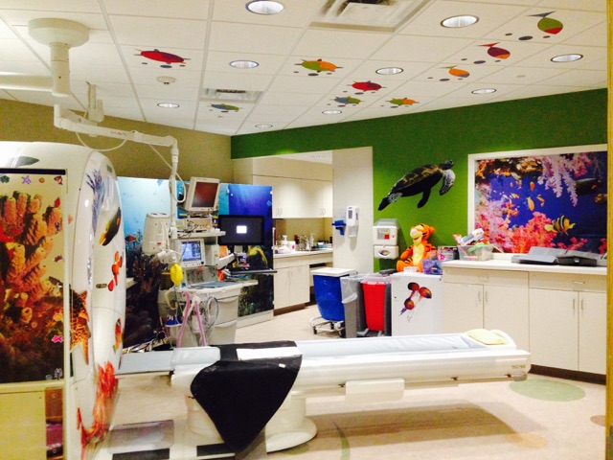
Here is a picture of the CT room your child will have their exam in.

If you have more questions related to preparing your child for this test you can contact the Radiology Child Life Specialist at 402-955-4042 or the Radiology dept. at 402-955-5602.

