Computerized Tomography (CT) Scan w/o Contrast

What is a CT scan?
A CT is a scan that takes detailed pictures of the body by using a combination of X-rays and a computer to create cross-sectional pictures of your organs, bones, and other tissues. This exam usually takes less than 5 mins.
What happens during a CT scan?
- A child life specialist or radiology nurse will meet with you and your child to help explain the procedure at your child’s developmental level, show you pictures of the camera/room the procedure will occur in, and help your child develop a positive coping plan.
- A radiology tech will bring you and your child into the CT room. Two adults are allowed to stay with your child. If pregnant, you will unable to stay in during the CT scan. If you’re planning on bringing other children with you, one adult will need to stay in the waiting area with them.
- Your child will see a red light shining down from the CT; this will help the radiology tech get your child in the correct position. A seat belt will be placed across their body.
- The bed will move through the CT scanner and come back out once or twice. During this time your child will need to hold their body still in order to get clear pictures.
  - Depending on type of exam your child may need to hold their breath.
How can you prepare and support your child for their CT scan?
- Use developmentally appropriate words to explain to your child what will happen.
- Have your child practice holding still at home before their scan, and holding their breath in and out.
- You are welcome to bring a comforting item (ex. blanket or stuffed animal) for the child to have with them during their scan.
- Participate in ONE VOICE, an initiative to promote a calming environment by limiting the amount of voices in the room so your child knows who to focus on (parent or procedural staff professional).
- Display a calm demeanor, your child picks up on your anxiety and often mirrors it.
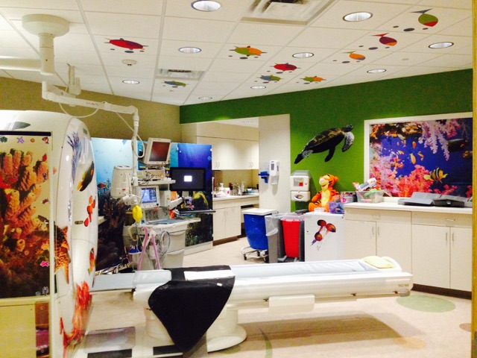

Here is a picture of the CT room your child will have their exam in.

If you have more questions related to preparing your child for this test you can contact the Radiology Child Life Specialist at 402-955-4042 or the Radiology dept. at 402-955-5602.

