Catheter Placement
What is a Catheter? A catheter is a small tube used to drain urine from the bladder.
What happens during a catheter placement?
- A child life specialist will meet with you and your child to help explain the procedure at your child’s developmental level, show you pictures of the camera/room the procedure will occur in, and help your child develop a positive coping plan.
- For the catheter placement, boys will lay flat on their back with straight legs. Girls will lie on their back making butterfly wings with their legs.
- The RN will clean your child’s opening where urine comes out (penis for boys and near the vagina for girls) with a cold, wet, brown soap on a cotton ball once, then will place lidocaine jelly on/into the area. The lidocaine will sit for 3 minutes to take effect, and then your child will be cleaned with two additional cold, wet, brown soaps followed by a dry cotton ball.
- When the catheter is being inserted your child may still feel an uncomfortable pinch-like feeling. Deep breathing can help lessen this sensation. Once the catheter is in the correct position your child may feel like they need to go to the bathroom. This is a normal sensation that decreases with relaxation and distraction.
- The RN will place small pieces of tape to keep the catheter in the correct spot for pictures.
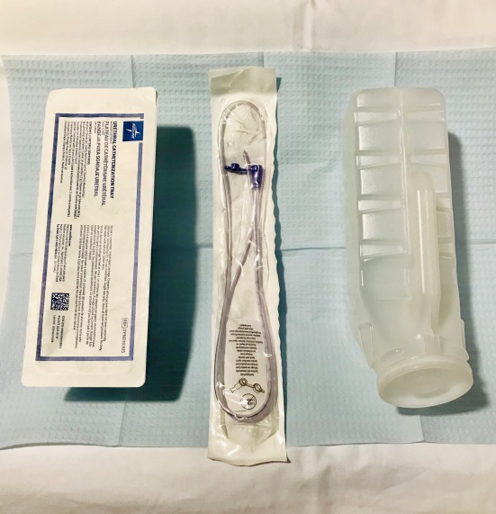
How can you prepare and support your child for an IV?
- Use developmentally appropriate words to explain to your child what will happen.
- Ask your doctor or nurse what pain management options are available for your child.
- Provide support by holding their hand, validating their feelings, and engaging your child in distraction such as looking at a book, playing a game, playing with toys, or watching a movie.
- Participate in One Voice, an initiative to promote a calming environment by limiting the amount of voices in the room so your child knows who to focus on (parent or procedural staff professional).
- Practice deep breathing at home by pretending to blow out birthday candles or blowing bubbles. (Deep breathing can help your child relax during stressful experiences.)
- Display a calm demeanor, your child picks up on your anxiety and often mirrors it.
If you have more questions related to preparing your child you can contact the Radiology Child Life Specialist at 402-955-4042.

