Intravenous Line (IV) Placement
What is an IV? An IV is a small straw used to put liquid substances directly into a vein.
What happens during an IV?
- First, your child will have a tourniquet (blue rubber band) placed to help the nurse see their veins better. This will give your child’s arm a tight squeeze or hug.
- Next, the nurse will use cold, wet soap to clean the area where the IV will be placed. You and your child can choose if Pain Ease would be beneficial for your child to help decrease pain associated with the IV placement. Pain Ease is sprayed for 10-15 seconds on the area where the IV will be placed; it creates a very cold feeling on the skin like putting your hand in snow.
- After soap or pain ease the IV will be placed. There will be an initial poke to get the straw in the right spot, once the straw is in the right spot the needle is removed and only the straw is left in your child’s vein. • The nurse will cover the area with tape in order to keep it in the right spot.
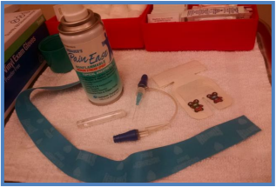
How can you prepare and support your child for an IV?
- Use developmentally appropriate words to explain to your child what will happen.
- Ask your doctor or nurse what pain management options are available for your child.
- Provide support by holding their hand, validating their feelings, and engaging your child in distraction such as looking at a book, playing a game, playing with toys, or watching a movie.
- Participate in One Voice, an initiative to promote a calming environment by limiting the amount of voices in the room so your child knows who to focus on (parent or procedural staff professional).
- Practice deep breathing at home by pretending to blow out birthday candles or blowing bubbles. (Deep breathing can help your child relax during stressful experiences.)
- Display a calm demeanor, your child picks up on your anxiety and often mirrors it.
If you have more questions related to preparing your child you can contact the Radiology Child Life Specialist at 402-955-4042.

