Magnetic Resonance Imaging (MRI) Scan w/ Contrast
What is a MRI Scan?
An MRI is a scan that uses a magnetic field to take detailed pictures of inside the body.
What happens during a MRI Scan?
Screening and Preparation
- A child life specialist or radiology nurse will meet with you and your child to help explain the procedure at your child’s developmental level, show you pictures of the camera/room the procedure will occur in, and help your child develop a positive coping plan.
- One adult is allowed to stay with your child during this exam. If pregnant, you will be unable to stay in during the MRI. If you’re planning on bringing other children with you, one adult will need to stay in the waiting area with them.
- Since MRI uses a magnetic field to take pictures, no metal is allowed into the MRI room. For this reason anyone who plans to go into the room must change into hospital scrubs and be screened by our staff to make sure each person is safe to go into the MRI scan room.
  - We have lockers for your personal items, clothes, jewelry, and electronics.
- If your child’s scan is scheduled with contrast they will get an intravenous line (IV) prior to their MRI. The IV will be placed by a radiology nurse (RN) in a procedure room, where there is a bed available, a chair for comfort holds, and a double chair that allows extra room for a caregiver.
- Once you and your child are in a comfortable position the RN will begin the IV process.
- Some abdominal MRI scans may be scheduled with contrast for your child to drink, flavor choices are available.
- A radiology tech will bring you and your child into the MRI room.
  - The radiology tech will help get your child get comfortable on the MRI bed. Specific positioning will be needed for each exam, and a seat belt will be placed across their body.
  - There will be headphones for your child to wear in order to hear their movie and the tech who is taking their pictures. Your child will be able to see their movie through a mirror either worn as glasses or connected to a head piece.
- The bed will move into the MRI camera until pictures are done which usually takes 30- 60 minutes. During this time your child will need to hold their body still.
- If your child is getting IV contrast a tech will come in the MRI room towards the end of their scan to inject the contrast through their IV. When the contrast is injected there is no sensation your child should feel. The radiology tech will take the IV out when they are finished with the MRI.
How can you prepare and support your child for their MRI Scan?
- Use developmentally appropriate words to explain to your child what will happen.
- Have your child practice holding still at home before their scan.
- Participate in One Voice, an initiative to promote a calming environment by limiting the amount of voices in the room so your child knows who to focus on (parent or procedural staff professional).
- Display a calm demeanor, your child picks up on your anxiety and often mirrors it.
- You are welcome to bring a non-metal comforting item (ex. blanket or stuffed animal) for the child to have with them during their scan.
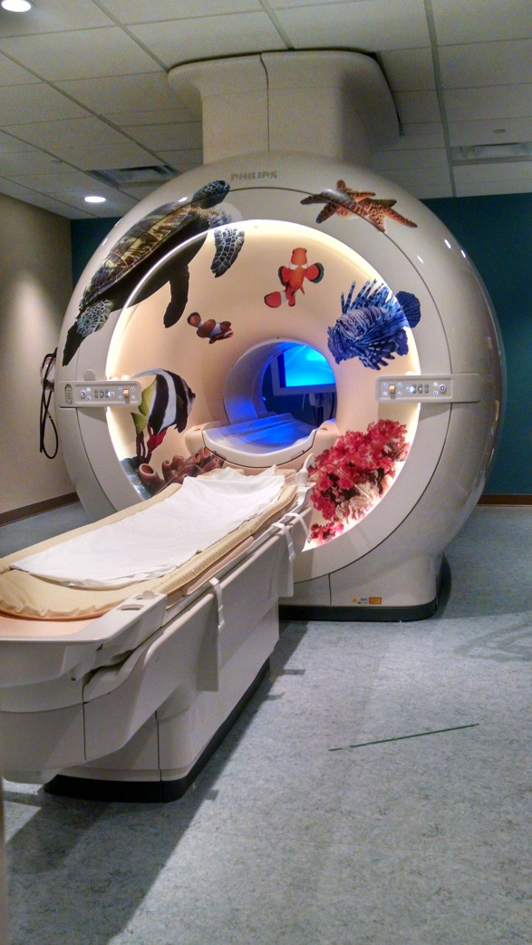
Here is a picture of the MRI scanner your child may have their exam in.
If you have more questions related to preparing your child for this test you can contact the Radiology Child Life Specialist at 402-955-4042 or the Radiology dept. at 402-955-5602.

