Nuclear Medicine Bone Scan
What is a Nuclear Medicine Bone Scan?
A Nuclear Medicine Bone scan uses a small amount of a radioactive tracer to diagnose and track several types of bone diseases. For this scan, your child will need an IV.
What happens during this scan?
- A child life specialist will meet with you and your child to help explain the procedure at your child’s developmental level, show you pictures of the camera/room the procedure will occur in, and help your child develop a positive coping plan.
- The radiology nurse (RN) will place your child’s IV. This process includes placing a tourniquet (blue rubber band) on their arm which will give your child’s arm a tight squeeze or hug and cleaning the skin with wet soap. Then there will be an initial poke to get the straw in the right spot, once the straw is in the right spot the needle is removed and only the straw is left in your child’s vein. The area will be covered with tape in order to keep the IV straw in the right spot during your child’s pictures.
- Two adults are allowed to accompany your child to the exam room. If pregnant, you will be unable to accompany your child due to the risks associated with radiation. If you’re planning on bringing other children with you, one adult will need to stay in the waiting area with them.
- You and your child will be taken to the nuclear medicine room where the nuclear medicine technologist will explain the remainder of the exam.
- Your child will receive a small amount of a radioactive tracer through their IV to start the test. This will not make them feel any different. Depending on the reason we are doing the exam we may take some images as the tracer is injected is to look at blood flow to a specific area.
- After the injection you will have a 3 hour wait time before you will return for imaging. No restrictions exist and you are allowed to leave the hospital. Upon return approximately 1 hour of imaging will take place.
- During the scan, your child will need to hold their body still in order to get clear pictures. Seatbelts are available if your child needs assistance holding their body still. During imaging your child can watch TV or pick a movie to watch.
- A bone scan generally has no side effects, and no follow-up care is needed. The radioactivity from the tracers is usually completely eliminated two days after the scan.
How can you prepare and support your child with their Nuclear Medicine Scan?
- Use developmentally appropriate words to explain to your child what will happen.
- You are welcome to bring a comforting item (ex. blanket or stuffed animal) for the child to have with them during their scan.
- Ask your doctor, nurse, or child life specialist what pain management options are available for your child.
- During the procedure provide support by holding their hands, validating their feelings, and engaging your child in distraction such as looking at a book, playing a game, or watching a movie.
- Participate in ONE VOICE, an initiative to promote a calming environment by limiting the amount of voices in the room so your child knows who to focus on (parent or procedural staff professional).
- Practice deep breathing at home by pretending to blow out birthday candles or blowing bubbles.
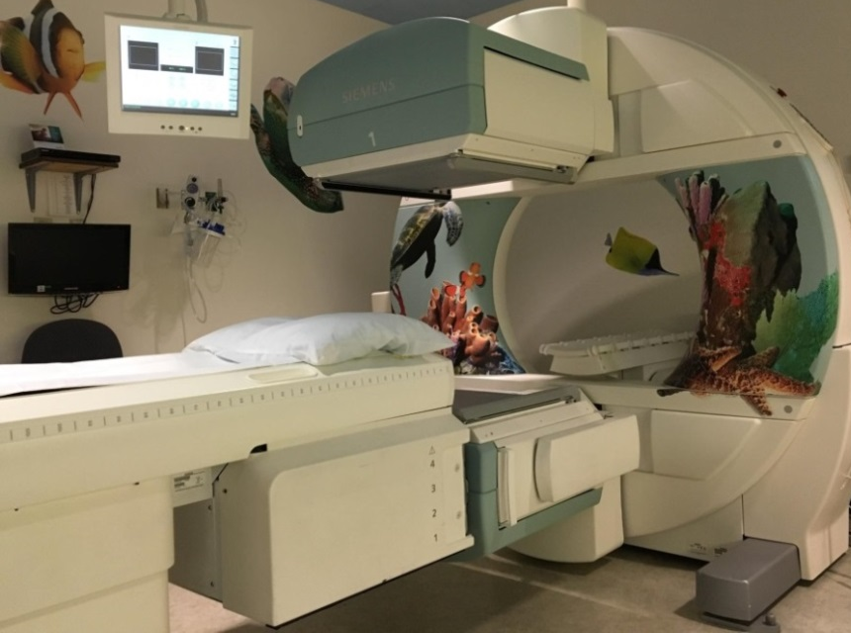
- Display a calm demeanor, your child picks up on your anxiety and often mirrors it.
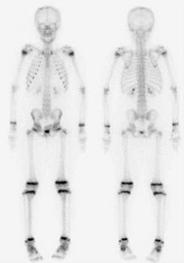
Here is a picture to help your child understand what the doctor will be looking at during a Bone scan.
This is a picture of the Nuclear Medicine room your child will have their exam in.

If you have more questions related to preparing your child for this test you can contact the Radiology Child Life Specialist at 402-955-4042 or the Radiology dept. at 402-955-5602.

