Nuclear Medicine Gastric Empty Scan
What is a Nuclear Medicine Gastric Empty Study?
A Nuclear Medicine Gastric Empty study uses small amount of a radioactive tracer mixed with a scrambled egg to determine how well the stomach is functioning.
What happens during this scan?
- Two adults are allowed to accompany your child to the exam room. If pregnant, you will be unable to accompany your child due to the risks associated with radiation. If you’re planning on bringing other children with you, one adult will need to stay in the waiting area with them.
- You will be brought into the nuclear medicine scan room where the nuclear medicine technologist will explain the exam.
- Your child will be asked to eat one scrambled egg, which is tagged with a small amount of a radiotracer, and drink a small amount of water and then lie down on the bed for imaging.
- Gastric Empty scans can be ordered as either a 2hr or 4hr study.
- During the scan, your child will need to hold their body still in order to get clear pictures. Seatbelts are available if your child needs assistance holding their body still. During imaging your child can watch TV or pick a movie to watch.
How can you prepare and support your child with their Nuclear Medicine Scan?
- Use developmentally appropriate words to explain to your child what will happen.
- If you question your child’s ability to eat a scrambled egg, practice with them prior to the day of the test.
- You are welcome to bring a comforting item (ex. blanket or stuffed animal) for the child to have with them during their scan.
- During the procedure provide support by holding their hands, validating their feelings, and engaging your child in distraction such as looking at a book, playing a game, or watching a movie.
- Participate in ONE VOICE, an initiative to promote a calming environment by limiting the amount of voices in the room so your child knows who to focus on (parent or procedural staff professional).
- Display a calm demeanor, your child picks up on your anxiety and often mirrors it.
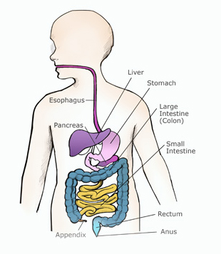
Here is a picture to help your child understand what the doctor will be looking at during the exam.

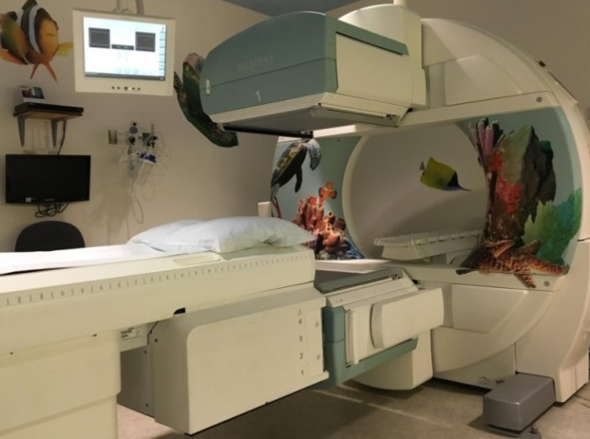
This is a picture of the Nuclear Medicine room your child will have their exam in.

If you have more questions related to preparing your child for this test you can contact the Radiology Child Life Specialist at 402-955-4042 or the Radiology dept. at 402-955-5602.

