Nuclear Medicine Mag 3 Scan
What is a Nuclear Medicine Mag 3 Study?
A Nuclear Medicine Mag 3 study uses small amounts of radioactive tracers to determine how well the kidneys are functioning. For this scan, your child will need a urinary catheter and IV.
What happens during this scan?
- A child life specialist will meet with you and your child to help explain the procedure at your child’s developmental level, show you pictures of the camera/room the procedure will occur in, and help your child develop a positive coping plan.
- Two adults are allowed to accompany your child to the exam room. If pregnant, you will be unable to accompany your child due to the risks associated with radiation. If you’re planning on bringing other children with you, one adult will need to stay in the waiting area with them.
- You and your child will be taken to the nuclear medicine room where your child may be asked to change into a hospital gown and then lie down on the bed.
- The radiology nurse (RN) will begin placing your child’s IV. This process includes placing a tourniquet (blue rubber band) on their arm which will give your child’s arm a tight squeeze or hug and cleaning the skin with wet soap. Then there will be an initial poke to get the straw in the right spot, once the straw is in the right spot the needle is removed and only the straw is left in your child’s vein. The area will be covered with tape in order to keep the IV straw in the right spot during your child’s pictures.
- For the catheter placement, boys will lay flat on their back with straight legs. Girls will lie on their back making butterfly wings with their legs.
- The RN will clean your child’s opening where urine comes out (penis for boys and near the vagina for girls) with a cold, wet, brown soap on a cotton ball once, then will place lidocaine jelly on/into the area. The lidocaine will sit for 3 minutes to take effect, and then your child will be cleaned with two additional cold, wet, brown soaps followed by a dry cotton ball.
- When the catheter is being inserted your child may still feel an uncomfortable pinch-like feeling. Deep breathing can help lessen this sensation. Once the catheter is in the correct position your child may feel like they need to go to the bathroom. This is a normal sensation that decreases with relaxation and distraction.
- The RN will place small pieces of tape to keep the catheter in the correct spot for pictures.
- The nuclear medicine technologist will explain the remainder of the exam.
- During the scan, your child will need to hold their body still in order to get clear pictures. Seatbelts are available if your child needs assistance holding their body still. During imaging your child can watch TV or pick a movie to watch.
How can you prepare and support your child with their Nuclear Medicine Scan?
- Use developmentally appropriate words to explain to your child what will happen.
- You are welcome to bring a comforting item (ex. blanket or stuffed animal) for the child to have with them during their scan.
- Ask your doctor, nurse, or child life specialist what pain management options are available for your child.
- During the procedure provide support by holding their hands, validating their feelings, and engaging your child in distraction such as looking at a book, playing a game, or watching a movie.
- Participate in ONE VOICE, an initiative to promote a calming environment by limiting the amount of voices in the room so your child knows who to focus on (parent or procedural staff professional).
- Practice deep breathing at home by pretending to blow out birthday candles or blowing bubbles.
- Display a calm demeanor, your child picks up on your anxiety and often mirrors it.
If you have more questions related to preparing your child for this test you can contact the Radiology Child Life Specialist at 402-955-4042 or the Radiology dept. at 402-955-5602.
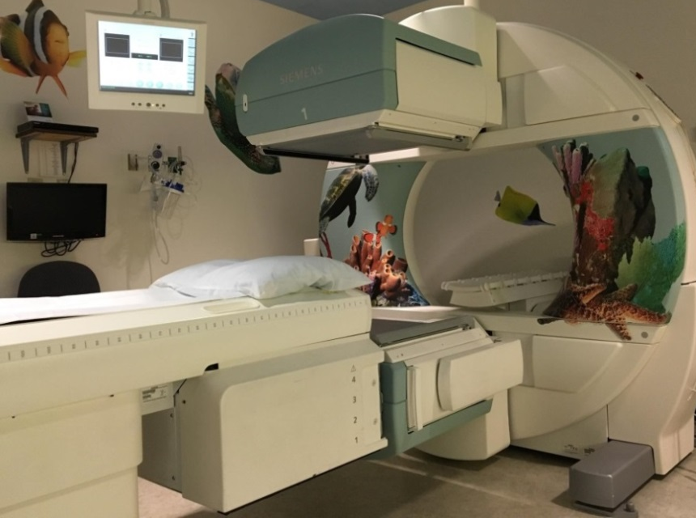
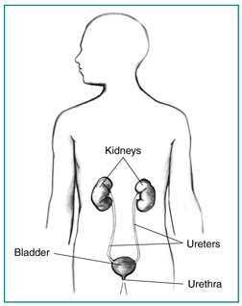
This is a picture of the Nuclear Medicine room your child will have their exam in.
Here is a picture to help your child understand what the doctor will be looking at during a MAG3.

