Nuclear Medicine Thyroid Uptake & Scan
What is a Nuclear Medicine Thyroid Uptake & Scan?
A thyroid uptake and scan is a nuclear medicine test that uses a small amount of a radioactive tracer to evaluate the size, location, and overall functional level of the thyroid gland.
What happens during this scan?
- Two adults are allowed to accompany your child to the exam room. If pregnant, you will be unable to accompany your child due to the risks associated with radiation. If you’re planning on bringing other children with you, one adult will need to stay in the waiting area with them.
- You and your child will be taken to the nuclear medicine room where the nuclear medicine technologist will explain the exam.
- At the first appointment your child will answer a questionnaire & then swallow a pill, about the size of an Advil liquid gel, which contains radioactive iodine.
- You will return 4 hours later to take a measurement to see how much of that iodine has made its way to the thyroid gland.
- The next morning you will return to take another measurement 24 hours after taking the pill, as well as approximately 1 hour worth of imaging.
- During the scan, your child will need to hold their body still in order to get clear pictures. Seatbelts are available if your child needs assistance holding their body still. During imaging your child can watch TV or pick a movie to watch.
How can you prepare and support your child with their Nuclear Medicine Scan?
- Use developmentally appropriate words to explain to your child what will happen.
- You are welcome to bring a comforting item (ex. blanket or stuffed animal) for the child to have with them during their scan.
- During the procedure provide support by holding their hands, validating their feelings, and engaging your child in distraction such as looking at a book, playing a game, or watching a movie.
- Participate in ONE VOICE, an initiative to promote a calming environment by limiting the amount of voices in the room so your child knows who to focus on (parent or procedural staff professional).
- Display a calm demeanor, your child picks up on your anxiety and often mirrors it.

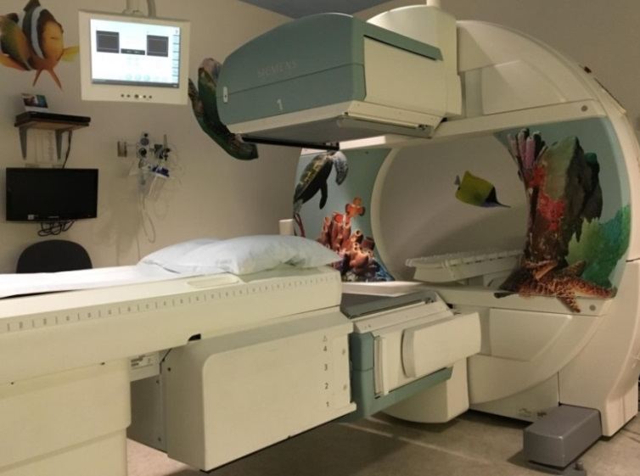
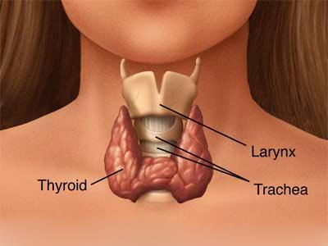
This is a picture of the Nuclear Medicine room your child will have their exam in.
Here is a picture to help your child understand what the doctor will be looking at during a Thyroid Uptake & Scan.

If you have more questions related to preparing your child for this test you can contact the Radiology Child Life Specialist at 402-955-4042 or the Radiology dept. at 402-955-5602.

