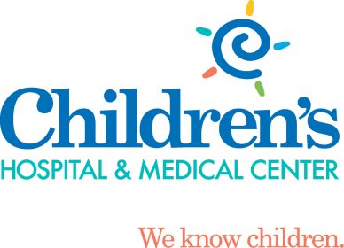
Patient/Family Education Nitrous Oxide for Sedation
Our goal at Children’s radiology department is to provide a safe, child-friendly environment. We can utilize different resources such as our child life specialists to make you and your child as comfortable as possible. One part of these resources is the use of nitrous oxide for procedures that may cause pain or anxiety.
What is Nitrous Oxide?

Nitrous Oxide is a very quick-acting inhaled sedation medicine that decreases discomfort and anxiety. It is sometimes called laughing gas, and is often given at the dentist office. As with all medicines, there are benefits, side effects, and risks. Be sure to discuss any questions with the doctor or nurse.

How it is given?

Your child will inhale the medicine through a mask, breathing in and out normally through the nose. Your child can pick the smell of the mask, such as bubble gum or strawberry. Sometimes, younger children resist the mask. If this happens, the nurse may gently help hold the mask in place.

The nitrous oxide will make your child feel relaxed and sleepy. It does not cause a deep sleep, as general anesthesia does. It will be given a few minutes before the procedure starts and may continue until it is finished.

For safety during sedation, a nurse will monitor your child until the medicine has worn off.

What are the side effects?

Nitrous oxide is safe for use in children and there are no long term side effects. These side effects may occur for a short time:
  - Headache
  - Nausea
  - Vomiting

What can I expect after the nitrous oxide is stopped?

Once the mask is removed, nitrous oxide wears off very quickly. Usually, children return to pre-nitrous status comfortably. Sometimes they may be a little disoriented and irritable, but this usually last only a very short time.

A nurse will monitor our child until the medicine has worn off. If your child is an outpatient, you must stay with him or her. Your child may eat right away unless there is a reason not to, such as another test. Once home, your child may go back to regular activities.
How can I help my child?

You are welcome to stay in the room while your child is receiving the nitrous oxide. For some procedures, you may be able to stay the entire time. Your child may find your presence during procedures helpful. Pregnant women are not allowed in the room because of extremely rare but possible risks to the baby.

Reassure and explain to your child in simple words what is being done and why. Always tell the truth. Remain calm, the more relaxed you and your child are, the easier the test will be. We are here to help both your child and you.

When should I call the doctor?

- Questions about the procedure or results
- Vomiting more than twice
- Extreme irritability
- Trouble arousing your child
- Signs of allergic reaction:
  - Fever or chills
  - Rash or hives
  - Wheezing
  - Trouble breathing – Call 911

What else do I need to know?

All children are different. Nitrous oxide does not work for everyone. The nurse and doctor will discuss other options with you if the procedure cannot be completed with nitrous oxide.

You may be asked to sign a consent form for some procedures.

Questions?
If you have questions about your child’s sedation, please call 402-955-5618. If you have more questions related to preparing your child for nitrous oxide you can contact the Radiology Child Life Specialist at 402-955-4042.

