Voiding Cystourethrogram (VCUG)

What is a VCUG? A VCUG is a test that takes pictures of the bladder, kidneys, ureters, and urethra to see how they are working together.

What happens during a VCUG?
- A child life specialist can meet with you and your child to help explain the procedure at your child’s developmental level, show you pictures of the room the procedure will occur in, and help your child develop a positive coping plan.
  - Medical Play can be used as a great way to help your child become familiar with the different medical equipment that they may see or experience during this appointment.
- A radiology tech will be in the fluoro room during the test. Two adults are allowed to accompany your child to the exam room. If pregnant, you will be unable to stay in during the pictures but are welcome to remain with your child during the catheter placement. If you’re planning on bringing other children with you, one adult will need to stay in the waiting area with them.
- Once in the fluoro room your child will need to change out of all of their clothes and into a hospital gown. After they have changed you can help your child up onto the table to lie down.
  - Boys will lay flat on their back with straight legs.
  - Girls will lie on their back making butterfly wings with their legs.
- You and your child can decide if lidocaine would be beneficial to help reduce sensation of catheter placement. Lidocaine can be used on children who are 2 years or older and able to lie still while uncovered for 3 minutes to let the lidocaine take effect.
  - During this time we can sing songs with your child, watch videos on an iPad, or play I Spy with items in the room.
- The radiology tech will clean your child’s opening where urine comes out (penis for boys and near the vagina for girls) with cold, wet, brown soap on a cotton ball three times followed by lidocaine and the placement of the catheter.
- When the catheter is being inserted your child may feel an uncomfortable pinch-like feeling. Deep breathing can help lessen this sensation. Once the catheter is in the correct position your child may feel like they need to go to the bathroom.
- The tech will place a small piece of tape to keep the catheter stay in the correct spot.
- At this point, one caregiver may remain with your child, while the other caregiver steps behind the lead glass window.
- The catheter is used to fill the bladder with contrast.
  - The contrast enables the doctor to see how the bladder fills and empties.
- While the bladder is filling with contrast the radiologist will take pictures of your child on their back and both sides using the fluoroscope camera.
- Once the bladder is full of contrast, your child will need empty their bladder (go to the bathroom) while lying under the fluoroscope camera. The catheter will slide out while they are emptying their bladder. Your child shouldn’t feel any discomfort.

How can you prepare and support your child with their VCUG?
- Use developmentally appropriate words to explain to your child what will happen.
  - Relate the pain, infections, or discomfort your child has been having and how important these pictures are to help him/her feel better.
  - The catheter is a small straw to help water go to their bladder (or where their potty sits) so the doctor can take pictures and see where that water goes.
  - The straw is not pokey, but will be an uncomfortable feeling that will go away soon after the straw is where it needs to be.
- You are welcome to bring a comforting item (ex. blanket or stuffed animal) for the child to have with them during their scan.
- Ask your doctor, nurse, or child life specialist what pain management options are available for your child.
- During the procedure provide support by holding their hands, validating their feelings, and engaging your child in distraction such as looking at a book, playing a game, playing with toys, or watching a movie. IPads are available to use as a distraction item as well.
- Participate in ONE VOICE, an initiative to promote a calming environment by limiting the amount of voices in the room so your child knows who to focus on (parent or procedural staff professional).
- Practice deep breathing at home by pretending to blow out birthday candles or blowing bubbles.
- Display a calm demeanor, your child picks up on your anxiety and often mirrors it.

If you have more questions related to preparing your child for this test you can contact the Radiology Child Life Specialist at 402-955-4042 or a Radiology Technician at 402-955-5710.
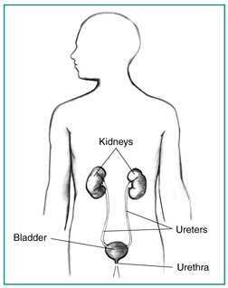
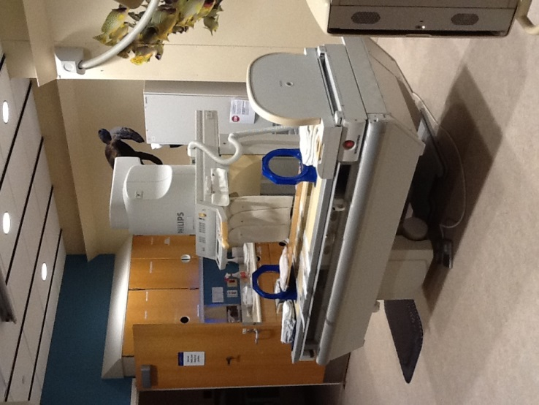
Here is a picture to help your child understand what the doctor will be looking at during a VCUG.
This is a picture of a Fluoro room your child may have their exam in.

