Water Soluble Enema

What is a Water Soluble Enema? A Water Soluble Enema is a test that takes pictures of the colon.

What happens during a Water Soluble Enema?
- A child life specialist can meet with you and your child to help explain the procedure at your child’s developmental level, show you pictures of the room the procedure will occur in, and help your child develop a positive coping plan.
- A radiology tech will be in the fluoro room during the procedure where the pictures will be taken. Two adults are allowed to accompany your child to the exam room. If pregnant, you will be unable to stay in during pictures but are welcome to remain with your child during tube placement. If other children are brought along, one adult will need to stay in the waiting area with them.
- Once in the fluoro room your child will need to change out of all of their clothes and into a hospital gown. You can help your child onto the exam table then they will lie on their side.
- The radiology tech will place the tube into your child’s anus. Your child may feel pressure and an uncomfortable feeling when the tube is being placed. Deep breathing can help lessen this sensation. The tech will use tape to keep the tube in the correct spot for pictures.
  - The Child Life Specialist can stay in the room to help distract your child with an iPad, songs, or deep breathing exercises.
- The tube is used to fill the rectum and colon with contrast. The contrast enables the doctor to see the structure of the digestive system on the pictures.
- At this point, one caregiver may remain with your child, while the other caregiver steps behind the lead glass window. While the colon is filling with contrast the radiologist will take pictures of your child on their back, stomach, and both sides using the fluoroscope camera. Your child will feel full when the contrast enters the colon. When the colon is full of contrast, the tech will take off the tape (using lotion to help the removing of the tape more comfortable) and take out the tube.
- Your child will need to empty his or her colon in their diaper or by using the restroom. There will be another picture taken after your child has emptied their colon.
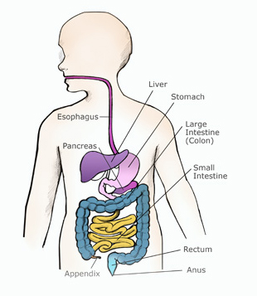
Here is a picture to help your child understand what the doctor will be looking at during one of these three exams.

How can you prepare and support your child with their Water Soluble Enema?
- Use developmentally appropriate words to explain to your child what will happen.
  - There will be a small tube that will go in their bottom, but to take big, deep breaths to help the tube go in.
  - Explain why the exam needs to happen and that you will be by his/her side during the entire procedure.
- You are welcome to bring a comforting item (ex. blanket or stuffed animal) for the child to have with them during their scan.
- During the procedure provide support by holding their hands, validating their feelings, and engaging your child in distraction such as looking at a book, playing a game, playing with toys, or watching a movie. IPads are available to use as a distraction tool as well.
- Participate in ONE VOICE
  - An initiative to promote a calming environment by limiting the amount of voices in the room so your child knows who to focus on (parent or procedural staff professional).
- Practice deep breathing at home by pretending to blow out birthday candles or blowing bubbles.
- Display a calm demeanor, your child picks up on your anxiety and often mirrors it.

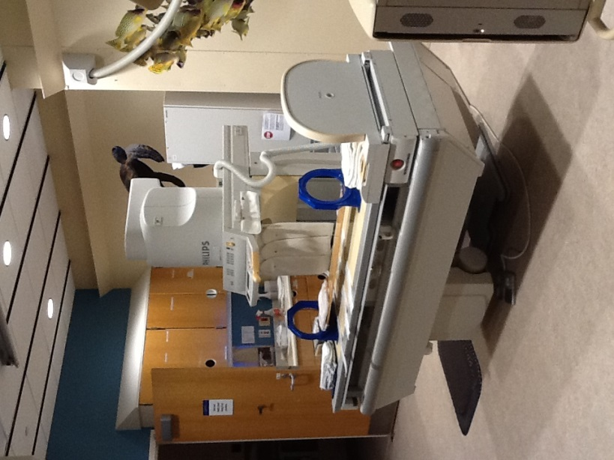
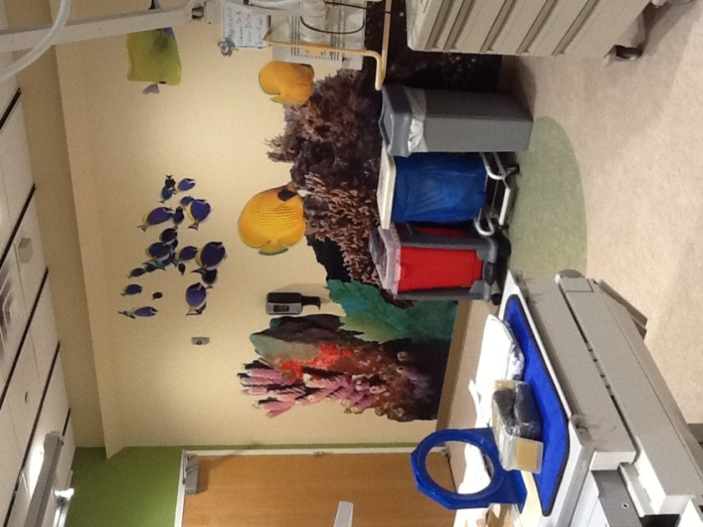
If you have more questions related to preparing your child for this test you can contact the Radiology Child Life Specialist at 402-955-4042 or a Radiology Technician at 402-955-5710.
These are pictures of a Fluoro room your child may have their exam in.

