SUN | MON | TUES | WED | THUR | FRI | SAT
 |  |  |  |  |  | 1
2 | 3  Yappy Hour  with Sven  5MS, 3:00  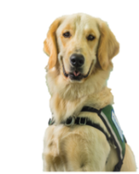 | 4  Healing Harps  Atrium, 12:00 | 5  Playroom Party  5MS, 4:30 | 6  Pet Therapy Dogs  2:00  Glow or  TV channel 44 | 7  Shrek  5:30  Glow Auditorium  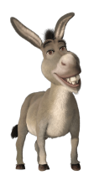 | 8
9 | 10  Pup Rally  with Sven and Sansa  5MS, 3:00  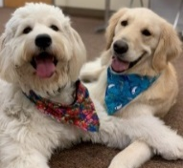 | 11  Child Life Playroom Activity  6MS, 4:00 | 12  Mini-Carnival  Atrium, 10:30  Playroom Party  5MS, 4:30 | 13  Pet Therapy Dogs  2:00  Glow or  TV channel 44 | 14  Moana  5:30  Glow Auditorium  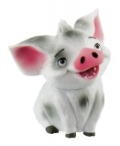 | 15
16 | 17  Yappy Hour  with Sven  5MS, 3:00 | 18  Mini-Carnival  Atrium, 10:30  Carnival &  Magic Show  With Joe Cole  Atrium, 5:30 | 19  Mini-Carnival  Atrium, 10:30  Playroom Party  5MS, 4:30 | 20  SPECIAL  FEATURE  Pet Therapy Dogs  2:00  Glow or  TV channel 44 | 21  5:30  Glow Auditorium | 22
23  30 | 24  Yappy Hour  with Sven  5MS, 3:00 | 25 | 26  Playroom Party  5MS, 4:30 | 27  Pet Therapy Dogs  2:00  Glow or  TV channel 44 | 28  Princess & the Frog  5:30  Glow Auditorium | 29
JUNE
**If no one is present within 15 minutes of the event it will conclude**

For those who are inpatient, a physician’s order is required to leave the unit.
Unfortunately, patients in isolation precautions may not attend the event.

