SUN | MON | TUES | WED | THUR | FRI | SAT
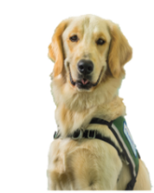 | 1  Yappy Hour  with Sven  5MS, 3:00 | 2  Healing Harps  Atrium, 12:00 | 3  Mini-Carnival  Atrium, 10:30  Playroom Party  5MS, 4:30 | 4 | 5  Finding Dory  5:30  Glow Auditorium | 6
7 | 8  Yappy Hour  with Sven  5MS, 3:00 | 9 | 10  Mini-Carnival  Atrium, 10:30  Playroom Party  5MS, 4:30 | 11  Pet Therapy Dogs  2:00  Glow or  TV channel 44 | 12  Sandlot  5:30  Glow Auditorium | 13
14 | 15  Pup Rally  with Sven and Sansa  5MS, 3:00  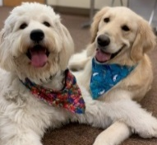 | 16  Healing Harps  Atrium, 12:00 | 17  Playroom Party  5MS, 4:30 | 18  SPECIAL  FEATURE  Pet Therapy Dogs  2:00  Glow or  TV channel 44 | 19  5:30  Glow Auditorium | 20
21 | 22  Yappy Hour  with Sven  5MS, 3:00 | 23 | 24  Mini-Carnival  Atrium, 10:30  Playroom Party  5MS, 4:30 | 25  Pet Therapy Dogs  2:00  Glow or  TV channel 44 | 26  Child Life Playroom Activity  4MS, 3:00  Lilo & Stitch  5:30  Glow Auditorium | 27
28 | 29 | 30 | 31  Playroom Party  5MS, 4:30
JULY
**If no one is present within 15 minutes of the event it will conclude**

For those who are inpatient, a physician’s order is required to leave the unit.
Unfortunately, patients in isolation precautions may not attend the event.

