SUN | MON | TUES | WED | THUR | FRI | SAT
 |  |  |  |  |  | 1
2 | 3  Yappy Hour  with Sven  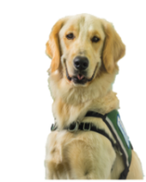  5MS, 3:00 | 4  Healing Harps  Atrium, 12:00 | 5  Playroom Party  5MS, 4:30 | 6  Pet Therapy Dogs  2:00  Glow or  TV channel 44 | 7  Mini-Carnival  Atrium, 10:30  Beauty & the Beast  5:30  Glow Auditorium | 8
9 | 10  Mini- Carnvial  Atrium, 2:30 | 11  Arts & Crafts  Atrium, 2:30  Child Life Activity  4MS, 4:30 | 12  Playroom Party  5MS, 4:30 | 13  Pet Therapy Dogs  2:00  Glow or  TV channel 44 | 14  Ella Enchanted  5:30  Glow Auditorium | 15
16 | 17  Notochords Creighton Instrumental  Atrium, 3:00 | 18 | 19  Playroom Party  5MS, 4:30 | 20  Pet Therapy Dogs  2:00  Glow or  TV channel 44 | 21  Wall-E  5:30  Glow Auditorium | 22
23 | 24  Pup Rally  with Sven and Sansa  5MS, 3:00  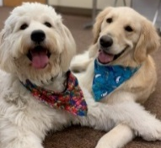  **If no one is present within 15 minutes of the event it will conclude**  For those who are inpatient, a physician’s order is required to leave the unit.  Unfortunately, patients in isolation precautions may not attend the event.  Due to phase 2 precautions siblings are not able to attend events outside of patient’s room. | 25 | 26  Playroom Party  5MS, 4:30 | 27  Pet Therapy Dogs  2:00  Glow or  TV channel 44 | 28  Gnomeo & Juliet  5:30  Glow Auditorium | 29
Febuary

