Children’s Hospital & Medical Center
CLABSI Prevention
Introduction
CLABSI (Central Line- Associated Blood Stream Infections) is the largest contributor to harm caused across the Children’s Hospital’s Solutions for Patient Safety (SPS) network. Central Venous Line (CVL) care follows the guidelines set by the Center for Disease Control, American Academy of Pediatrics, Infusion Nurses Society, Oncology Nursing Society, Children’s Hospital Association and Solution for Patient Safety Collaborative guidelines for the prevention of CLABSI. CVLs include central venous lines, central venous catheters, infusaports, peripherally inserted central venous catheters, subclavian, and short-term femoral and jugular venous catheters, femoral arterial lines, umbilical venous catheters, umbilical arterial catheters, hemodialysis catheters, plasmapheresis catheters, atrial lines, and ECMO cannulas.
CLABSI Communication
CLABSI updates will be communicated by inpatient Medical Directors monthly to their unit providers. All other communication and updates will come via myChildren’s or The Pulse as necessary.
Line Insertion Prevention Bundle
Central line insertions will be audited by trained staff on all inpatients units, in the ED, FCC, Cath Lab and OR. Unit CLABSI leadership will receive monthly report of their line insertion audits and will follow up with staff who are noncompliant. The following elements will be audited to assure our line insertion bundle compliance helps us in CLABSI prevention:
- Handy hygiene- Perform hand hygiene procedures, either by washing hands with conventional soap and water or with alcohol-based hand rubs. Handy hygiene should be performed before and after palpating catheter insertion sites as well as before and after inserting, replacing, accessing, repairing or dressing any intravascular catheter. Palpation of the insertion site should not be performed after the application of antiseptic, unless aseptic technique is maintained.
- CHG Scrub- ChloraPrep will be applied to skin in sterile fashion using a back and forth motion to completely wet the treatment area for 30 seconds, unless line insertion is femoral. Femoral line insertions will be scrubbed with CHG for 2 minutes. Allow site to air dry for at least 1 minute and until visibly dry. For children less than 2 months corrected age, remove ChloraPrep after one minute of drying with a sterile saline wipe. The wipe will be completed using a circular motion; starting at the center of the insertion/puncture site and working out to approximately 2 inches. Do not re-wipe across the area maintaining sterile field.
- No iodine ointment- Povidone iodine may be used per practitioner request, but must dry on skin for at least 2 minutes before skin puncture.
- Use of a sterile probe cover- If the provider should choose to use an ultrasound probe during central line insertion, it must be covered with a sterile probe cover.
- Maximal sterile barrier for providers and patients- Full protection includes sterile drape that covers the patient’s entire body, hat, mask, sterile gown and sterile gloves. For staff and any family members at bedside not assisting with the line insertion masks must be worn at all times. If staff at bedside are assisting directly in sterile field they will wear sterile gown and sterile gloves as well.
- Doors closed- When a central line is being inserted the door should remain closed at all times to prevent traffic in an out of the room and possible contamination of sterile procedure and products.
In addition to the evidence-based bundle elements, our organization also utilizes antimicrobial and hemostatic patches on central lines. Guardiva patches are placed as appropriate for patients over 2 months of age (corrected gestational age 48 weeks). Algidex patches are placed as appropriate for patients under 2 months of age or those patients with a documented CHG allergy.
The StatSeal may be placed as appropriate with a central line insertion to assist in stopping blood and exudates to decrease the number of unnecessary dressing changes. The StatSeal may be placed on PICCs, CVC, peripheral arterial catheters, and temporary hemodynamic support devices.
In any critical situation, consider intraosseous (IO) access at any time.
Inpatient Line Insertion Algorithms
In order to assist providers in determining the appropriate line type for patients there is a line insertion algorithm available within the Policy PTCR147h: Intravenous Therapy Care & Management.
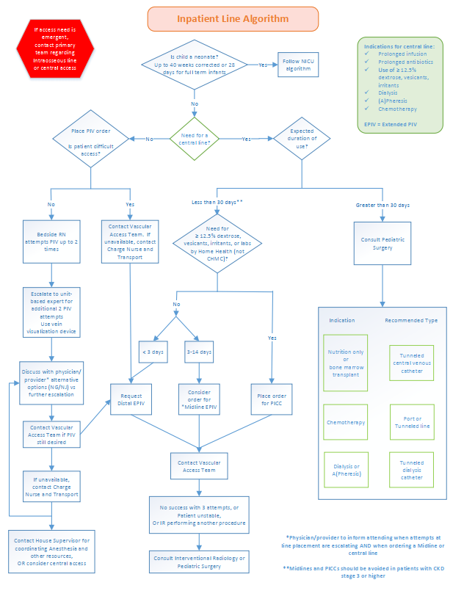
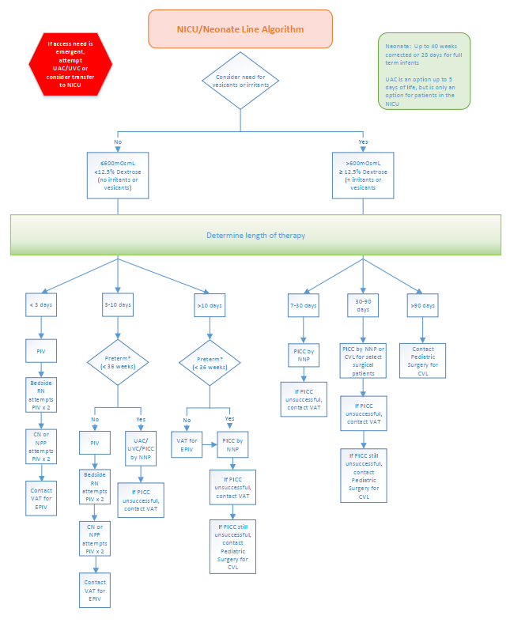

Maintenance Prevention Bundle
- Daily discussion of line- Discussion between the bedside and medical care team members regarding the central line will occur daily. This discussion will include the necessity of line, function of the line and any problems, and the frequency of access and utilization of the line. Documentation of the daily discussion in the medical record should be included in the Daily Progress Note.
  - Consider bundling labs and line entries.
  - Consider timely removal of all unnecessary lines, lines that are occluded or having problems. Consider use of PIVs, midlines, or extended dwell catheters when appropriate.
  - A regular assessment of the dressing to assure clean/dry/occlusive
- Regular assessment of dressing to assure clean/dry/occlusive- Dressings will be assessed and changed as needed when damp, loosened, or visibly soiled.
- Standardized access procedure- Hand hygiene will be performed and clean gloves will be donned prior to every line access. The cap/access point will be vigorously scrubbed in a back and forth motion across the top and sides with an alcohol wipe for at least 15 seconds and allowed to dry for a minimum of 15 seconds and until visibly dry.
- Standardized dressing, cap and tubing change procedures/timing- All central line dressing changes require 2 people except when performed in Hematology/Oncology Clinic, Infusion Center, and Children’s Home Health Care. All inpatient units will refer dressing change needs to a member of the Dressing Change Team. Transparent dressings with no gauze will be changed every 7 days and PRN if the dressing integrity is compromised. At any time there is concern for worsening in skin condition, consult the Wound Service. When a CVL cap is in place it will be changed upon admission to an inpatient area unless previously changed that day at Children’s such as during clinic visit, every 96 hours, if it is contaminated or soiled, every 24 hours when patient is receiving TPN/lipids, and following Propofol and blood product infusions. When caps, tubing and dressings are changed the doors/curtains will be closed, a STOP signed placed, and all present in the room are required to wear a mask.
- CHG treatments- Patients who are less than 2 months of age and who were born at greater than 28 weeks will receive a CHG treatment on Monday, Wednesday and Friday. Patients who were born at less than 28 weeks gestation must be 14 days old before starting CHG. All other patients with a central line will receive a CHG treatment daily.
Nursing policy Patient Care: Intravenous therapy care & management (PTCR147h) governs day-to-day line care.
Expectations
It is expected that providers will follow all bundle elements anytime they are inserting a line as well as the maintenance bundle throughout the life of the line. Staff and Providers are empowered through Error Prevention to speak up when bundle elements are not followed as their personal commitment to safety. Any provider requesting a product or equipment that pertains to vascular access will have to go through the Vascular Access Oversight Committee’s trial process.
If you have questions, concerns, or suggestions regarding CLABSI prevention please email CLABSI@childrensomaha.org. Your emails will be reviewed by the Vascular Access Oversight Committee.
Thank you for your commitment to CLABSI prevention and No Harm,
The Vascular Access Oversight Committee

References
1. CDC Guidelines for Prevention of Catheter –related Infections. Clinical Infectious Diseases 2011;52(9):e162–e193
2. Quality Transformation Efforts Decreasing PICU Catheter-Associated Bloodstream Infections: NACHRI's, Marlene R. Miller, Michael Griswold, J. Mitchell Harris, II, Gayane Yenokyan, Charles Huskins, Michele Moss, Tom B. Rice, Debra Ridling, Deborah Campbell, Peter Margolis, Stephen Muething and Richard J. Brilli , W. Pediatrics published online Jan 11, 2010; DOI:10.1542/peds.2009-1382
3. A Hospital-wide Quality-Improvement Collaborative to Reduce Catheter-Associated Bloodstream Infections: Derek S. Wheeler, Mary Jo Giaccone, Nancy Hutchinson, Mary Haygood, Pattie Bondurant, Kathy Demmel, Uma R. Kotagal, Beverly Connelly, Melinda S. Corcoran, Kristin Line, Kate Rich, Pamela J. Schoettker and Richard J. Brilli Pediatrics; originally published online September 19, 2011; DOI: 10.1542/peds.2010-2601

