Fruitful 2021 COVID-19 Vaccine Campaign
Phase 3: Social Strategy
Post 1
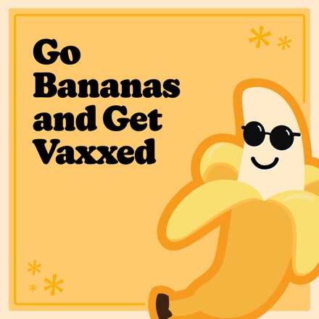
Facebook
Make this year more appealing by protecting teens against COVID-19.

The CDC and American Academy of Pediatrics recommend that youth 12 years + be vaccinated
lickety-split.
Learn more at @childrensomaha’s COVID-19 resource page: https://childrensomaha.org/covid
Instagram
Make this year more appealing by protecting teens against COVID-19.

The CDC and American Academy of Pediatrics recommend that youth 12 years + be vaccinated
lickety-split.

Visit ChildrensOmaha.org/covid for more information.
.
.
.
#covid_19 #covid #vaccinessavelives #nebraska #fruitful21

Post 2

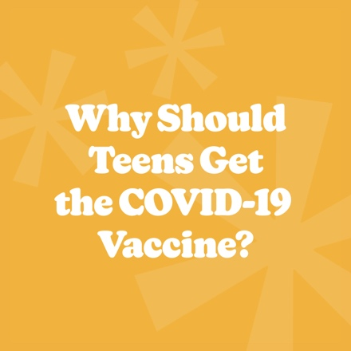
Facebook
Go bananas and get vaxxed! The CDC now recommends everyone 12+ be vaccinated against COVID-19.

For answers to frequently asked questions about the COVID-19 vaccination for teens, go to: https://www.childrensomaha.org/wp-content/uploads/2021/09/Fruitful-2021-FAQ.pdf
Instagram
Go bananas and get vaxxed! The CDC now recommends everyone 12+ be vaccinated against COVID-19.

For answers to frequently asked questions about the COVID-19 vaccination for teens, visit ChildrensOmaha.org/fruitful2021.
.
.
.
#covid_19 #covid #vaccinessavelives #nebraska #fruitful21

Post 3
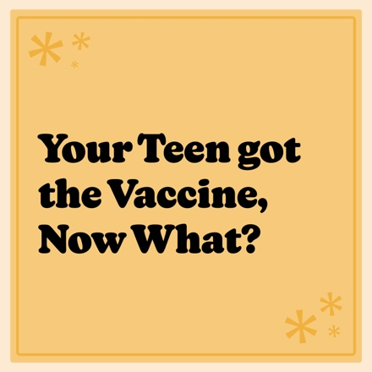
Facebook
Find out what’s next for teenagers once they’ve been vaccinated against the COVID-19 virus in this @childrensomaha article at: https://www.childrensomaha.org/health-news/your-teen-has-been-vaccinated-now-what/

Instagram
Find out what’s next for teenagers once they’ve been vaccinated against the COVID-19 virus
at ChildrensOmaha.org/covid.
.
.
.
#covid_19 #covid #vaccinessavelives #nebraska #fruitful21

Post 4
Facebook
Everyone 12 and older is now eligible for COVID vaccines!

Say yes to friends. Say yes to hanging out. Say yes to…

See what teens can say “yes” to again once they are vaccinated at: https://www.youtube.com/watch?v=ehdCtHOx50g
Instagram
Everyone 12 and older is now eligible for COVID vaccines!

Say yes to friends. Say yes to hanging out. Say yes to…

See what teens can say “yes” to again once they are vaccinated by clicking on the “YES! Video (YouTube) link at: ChildrensOmaha.org/fruitful2021.
.
.
.
#covid_19 #covid #vaccinessavelives #nebraska #fruitful21

Post 5

Facebook
The Delta variant of COVID-19 is 200% more transmissible than other variants.
Let’s protect more teens from COVID! Getting eligible teens vaccinated is essential to protecting them from the virus and slowing community spread. Learn more about returning to school safely at:
https://www.childrensomaha.org/wp-content/uploads/2021/08/NCHEA-DELTA-2021-FINAL.pdf

Instagram
The Delta variant of COVID-19 is 200% more transmissible than other variants.

Let’s protect more teens from COVID! Getting eligible teens vaccinated is essential to protecting them from the virus and slowing community spread.

Learn more by clicking on the Returning to School Safely information sheet at: ChildrensOmaha.org/fruitful2021.
.
.
.
#covid_19 #covid #vaccinessavelives #nebraska #fruitful21

