5+ Fruitful COVID-19 Vaccine Campaign
Social Strategy
Post 1
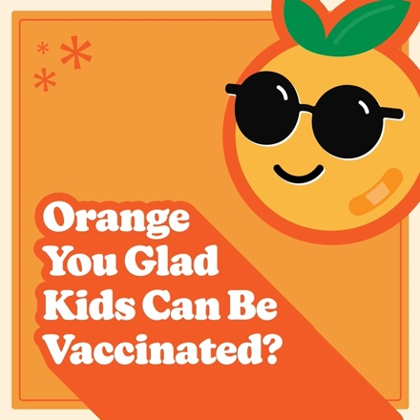
Facebook
You can’t knock the fact that the CDC recommends everyone 5 years and older get the COVID-19 vaccine. Do your part to protect your friends and community by getting vaccinated as soon as possible.
Learn more at @childrensomaha’s COVID-19 resource page: https://childrensomaha.org/covid
Instagram
You can’t knock the fact that the CDC recommends everyone 5 years and older get the COVID-19 vaccine. Do your part to protect your friends and community by getting vaccinated as soon as possible.

Visit ChildrensOmaha.org/covid for more information.
.
.
.
#covid_19 #covid #vaccinessavelives #nebraska #fruitful

Post 2
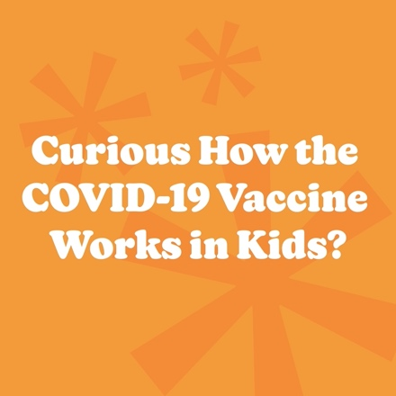
Facebook
Are you curious how the COVID-19 vaccine works to protect your child? Watch this short video from the American Academy of Pediatrics: https://www.youtube.com/watch?v=YOlrNlvEiMw
Instagram
Are you curious how the COVID-19 vaccine works to protect your child? Watch this short video from the American Academy of Pediatrics: https://www.youtube.com/watch?v=YOlrNlvEiMw
.
.
.
#covid_19 #covid #vaccinessavelives #nebraska #fruitful

Post 3
Facebook
Let’s make it a fruitful school year by getting as many people vaccinated as possible.

Please do your part to protect against this potentially harmful virus by getting everyone 5 years and older vaccinated as soon as possible.

Learn more at @childrensomaha’s COVID-19 resource page: https://childrensomaha.org/covid

Instagram
Let’s make it a fruitful school year by getting as many people vaccinated as possible.

Please do your part to protect against this potentially harmful virus by getting everyone 5 years and older vaccinated as soon as possible.

Visit ChildrensOmaha.org/covid for more information.

#covid_19 #covid #vaccinessavelives #nebraska #fruitful

Post 4
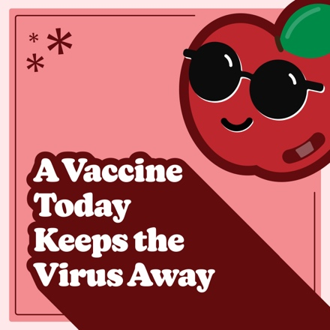
Facebook
Protect kids against COVID-19.

The CDC and American Academy of Pediatrics recommend that youth 5 years and older be vaccinated. Let’s pick good choices and make sure as many people as possible get vaccinated.
Learn more at the @childrensomaha’s COVID-19 resource page: https://childrensomaha.org/covid
Instagram
The CDC and American Academy of Pediatrics recommend that youth 5 years and older be vaccinated.

Let’s pick good choices and make sure as many people as possible get vaccinated.

Visit ChildrensOmaha.org/covid for more information.
.
.
.
#covid_19 #covid #vaccinessavelives #nebraska #fruitful

Post 5
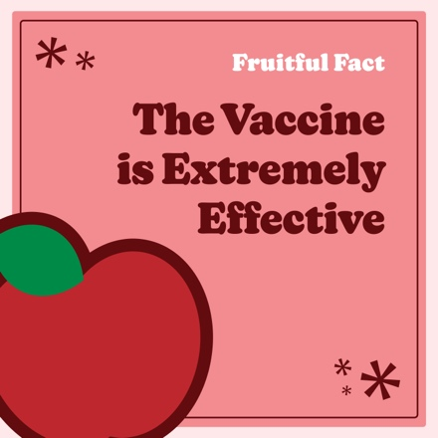
Facebook
A vaccine today keeps the virus away!
The COVID-19 vaccine can prevent nearly 100% of severe illness and death from the virus in healthy people.
Get more fruitful facts from the experts at @ChildrensOmaha at: https://www.childrensomaha.org/wp-content/uploads/2021/11/School-COVID-Vaccine-Fact-Sheet.pdf
Instagram
A vaccine today keeps the virus away!
The COVID-19 vaccine can prevent nearly 100% of severe illness and death from the virus in healthy people. Get more fruitful facts from the experts at @ChildrensOmaha at ChildrensOmaha.org/covid.
.
.
.
#covid_19 #covid #vaccinessavelives #nebraska #fruitful

Post 6
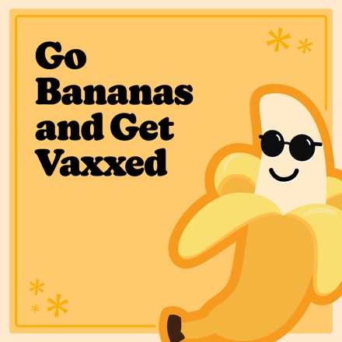
Facebook
Make this year more appealing by protecting kids against COVID-19.

The CDC and American Academy of Pediatrics recommend that youth 5 years and older be vaccinated
lickety-split.
Learn more at @childrensomaha’s COVID-19 resource page: https://childrensomaha.org/covid
Instagram
Make this year more appealing by protecting kids against COVID-19.

The CDC and American Academy of Pediatrics recommend that youth 5 years and older be vaccinated
lickety-split.

Visit ChildrensOmaha.org/covid for more information.

#covid_19 #covid #vaccinessavelives #nebraska #fruitful

Post 7
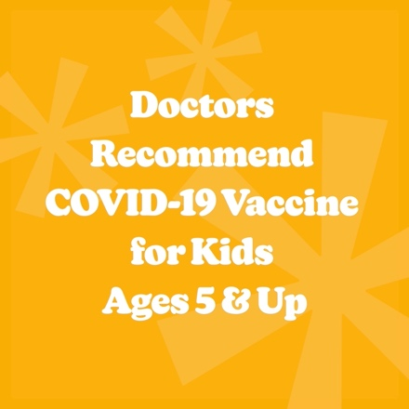

Facebook
Go bananas and get vaxxed! Doctors recommend everyone 5 years and older be vaccinated against COVID-19.

For answers to frequently asked questions about the COVID-19 vaccination for kids, go to: https://www.childrensomaha.org/wp-content/uploads/2021/11/COVID-Vaccine-FAQ.pdf

Instagram
Go bananas and get vaxxed! Doctors recommend everyone 5 years and older be vaccinated against COVID-19.

For answers to frequently asked questions about the COVID-19 vaccination for kids, visit ChildrensOmaha.org/fruitful.
.
.
.
#covid_19 #covid #vaccinessavelives #nebraska #fruitful

