Children’s Hospital & Medical Center
Medical/Allied Health Staff Review of Infection Control Procedures
Hand Hygiene
All direct patient caregivers and other hospital personnel are to practice hand and skin hygiene
in circumstances in which disease could be transmitted to themselves or others. Children’s utilizes the Biovigil hand hygiene monitoring system to improve compliance; this system provides visual cues that empower parents and all employees to encourage and enforce hand hygiene.
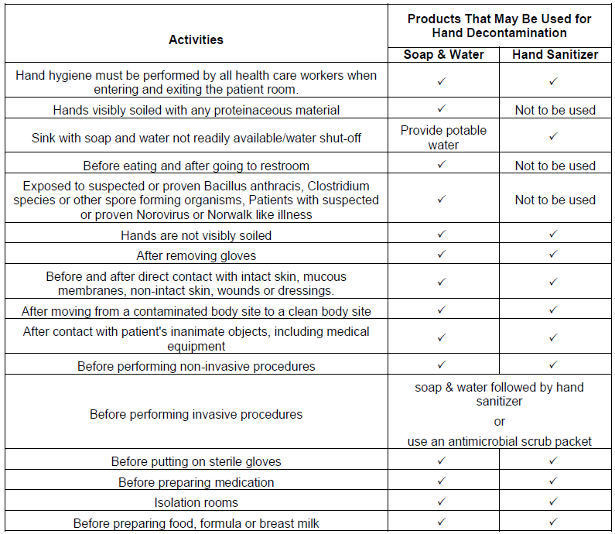
Respiratory hygiene and cough etiquette
All health care workers will practice Respiratory Hygiene/Cough Etiquette.
- All employees are to practice “sneeze or cough into sleeve” or
- Cover the mouth/nose with a tissue when coughing
- Hand hygiene after contact with respiratory secretions, coughing, or sneezing
- Prompt disposal of used tissues
- Employees who are symptomatic of any respiratory illness are to wear a mask and
maintain spatial separation for the protection of others
- Employees who are symptomatic of any respiratory illness while at work are to report to
Employee Health for evaluation.
Disease specific isolation and standard precautions
Standard Precautions are used for the care of all patients at Children's Hospital & Medical Center. When transmissible diseases or organisms are known or suspected, specific isolation precautions will be added. Isolation precautions should be used if signs/symptoms, testing or diagnosis indicate a potential infectious diagnosis. If infectious disease testing is ordered, isolation precautions should not be discontinued until appropriate therapy is initiated or testing is final and negative.

Duration of Illness for the purpose of isolation precautions is defined as the time during which human to human transmission is possible, not necessarily on the presence of signs and symptoms of disease. Duration of illness is usually based on the AAP Red Book, under the two headings of “Epidemiology” and “Isolation of the Hospitalized Patient” for specific organisms and diseases; or on CDC guidelines.

The “Disease Specific Isolation and Standard Precautions Table” is available from the intranet home page, policies tab, if you have specific questions about appropriate isolation or precautions.

Blood and body fluid exposure

To prevent a blood & body fluid exposure, appropriate use of Personal Protective Equipment (PPE) must be used. Should you come in contact with body fluids or bloody body fluids (through a needle stick, human bite, prolonged exposure to broken skin or a splash to the eyes or mucous membranes) the following must occur
- Provide safety or first aid as needed. If emergency or severe injury to any adult call 911.
  - If blood and/or body fluid exposure to eye or mucus membrane, rinse with water for 20 minutes.
  - If blood and/or body fluid exposure to skin or from a sharp, wash with soap and water.
- If recipient of exposure is off-site and is associated with a physician office or health care
organization, a written request for follow-up is required. The written request must include
information that the exposure was considered significant, the name of the person confirming
the exposure significance, the physician to whom the results will be sent and who is
responsible for arranging posttest counseling. Present policies and procedures will be
followed after this information is received.
- Notify Employee Health, Infection Prevention, Charge Nurse and Administrative Coordinator.
- Retain donor and if applicable recipient until testing is initiated and the involved individual is released by Employee Health or Infection Prevention.
- Secure all devices, equipment, specimens or articles involved and place in a biohazard bag. Label with the employee’s name, RN or Supervisor that is knowledgeable of the event, patient/visitor/family member’s name, date and time of occurrence. Refrigerate item in specimen refrigerator until released by Employee Health or Infection Prevention.

All testing will be done through Children’s Pathology Laboratory. The testing schedule will be
determined by the hospital epidemiologist.
Complete an Eye on Safety report.

Bloody body fluid spills: If you are not trained to clean up this type of spill please:
- Provide safety first, stay near the spill and do not allow others or yourself to become exposed
- Direct another employee to call 8999 and ask for a body fluid spill clean up
Dispose of items that have drippable, pourable bloody body fluids in a red biohazardous trash bag. All sharps (needles) are never to be re-capped and are to be placed in a red biohazardous sharps box.

The Exposure Control Plan is available on the intranet in PolicyTech under resources-plans-infection prevention.

Sharps Handling

Sharp handling procedures are to be followed in all settings and with patient-owned equipment. All disposable contaminated sharps are to be handled as biohazards waste and are to be discarded in a biohazard-labeled puncture resistant container. Types of sharps include hypodermic needles, scalpels, disposable blades, pipettes, safety pins, and any breakable containers and glass products.

TB Mask Fitting
TB mask fitting is required for any person that has the potential to care for known or suspected TB patients, H1N1 patients that will be having a procedure that could cause aerosolization, patients with Middle East Respiratory Syndrome (MERS-CoV), Monkey Pox, Small Pox, SARS or Avian flu and other emerging highly infectious diseases. Mask fitting must be performed prior to caring for such patients. Mask fitting is required per the OSHA Federal Mandate (29 CFR 1910.134) and must be completed annually.

I have read and will comply with the Children's Review of Infection Control Procedures
_____________________ ______________________________________________________
Date Provider’s Signature

References
1 Tabers Cyclopedic Medical Dictionary; Edition 17; Clayton L. Thomas MD, MPH, Editor; F.A.Davis Company; Philadelphia;1993
2 Dr. Archana Chatterjee, Children’s Hospital Epidemiologist and the Centers for Disease Control and Prevention “Fact Sheet” Norovirus in Healthcare Facilities released April 21, 2005

