Children’s Hospital & Medical Center Chronic Pain Clinic Intake Questionnaire

Directions: Please answer each of the following questions by writing in or choosing the best answer. Please mail these forms back to our office in order to be scheduled for an appointment:

Children’s Hospital & Medical Center- Chronic Pain Clinic
8200 Dodge Street
Omaha, NE 68114

Clinic Phone: 402-955-7170 (option 5 to reach clinic secretary)
Fax: 402-955-5596

Patient Name: ________________________________________ Date of Birth: _________________________

FAMILY’S INFORMATION
Mother
Name: ______________________________________ Age: ________

Marital Status: | Single | Married | Separated | Divorced | Widowed | Remarried
Work: | Full-time | Part-time | Unemployed

Occupation: _________________________________________

Father
Name: ______________________________________ Age: ________

Marital Status: | Single | Married | Separated | Divorced | Widowed | Remarried
Work: | Full-time | Part-time | Unemployed

Occupation: _________________________________________

BIRTH / DEVELOPMENTAL HISTORY

Were there any problems during pregnancy? Yes No Explain: __________________________________
What was your child’s birth weight? ____________________
Did your child have any complications during or after delivery? ______________________________________
Did your child have any problems noted at birth (ex: torticollis, birth defects, etc.)? ______________________
__________________________________________________________________________________________
Do you have any concerns with your child’s development? __________________________________________
__________________________________________________________________________________________

PAIN HISTORY

The reason my child is attending this clinic is because of:
Abdominal pain | Body pain | Joint pain | Pelvis pain
Arm pain | Chest pain | Leg pain | Other (Specify)
Back pain | Headaches | Neck pain

Please mark as many locations on the figure below as needed to indicate your pain.

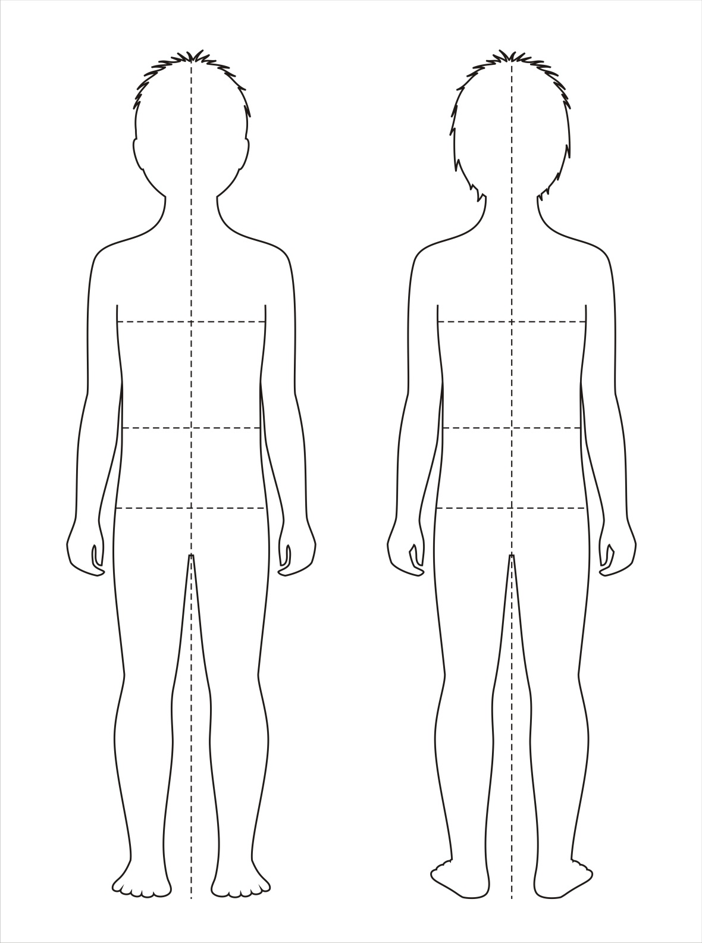

If you have pain in more than one place on your body, which part hurts the most? _______________________

When did the pain problem start? (month/year) _____________________________

Which of the following best describes how the pain began (mark all that apply)
Motor vehicle accident | After a fall | Just began
Came on gradually | After an illness | After surgery
Other (Please explain)

Mark all the words that describe your pain
Aching | Dull | Miserable | Sharp | Stretching
Biting | Electric like | Pin and needles | Shooting | Throbbing
Burning | Grabbing | Pricking | Squeezing | Tingling
Cold | Horrible | Pounding | Sore | Unbearable
Cutting | Hot | Pulling | Stabbing | Other (Specify)
Deep | Itching | Scraping | Stinging

What level of pain do you typically have? (Circle a number below)
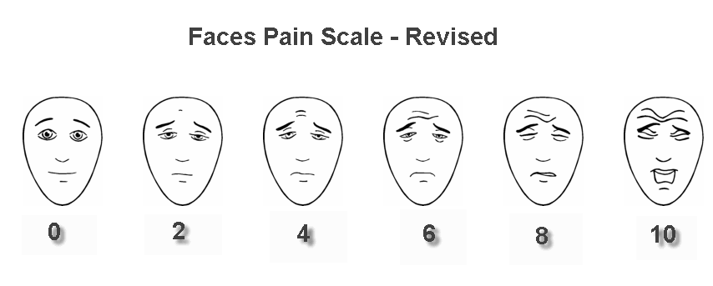
0 = no pain 10 = worst pain ever

When your pain is at worst, how strong it is? (Circle a number below)
0 = no pain 10 = worst pain ever

When your pain is tolerable, how strong it is? (Circle a number below)
0 = no pain 10 = worst pain ever

Since your pain started it has: Increased Decreased Stayed the same

Is your pain: Always there Comes and goes Is always there but sometimes gets worse

What affects your pain? (Check all that applies)

 | Makes it better | Makes it worse | Doesn’t change it | Didn’t try
Activity/Movements
Standing
Walking
Running
Sitting
Bending
Lifting
Lying down/Rest
Stress/Emotions
Noise
Massaging or Rubbing
Cold
Heat
Other (please describe)

What treatments have you tried for your pain? (Check all that apply)

 | Makes it a little better | Makes it a lot better | Doesn’t change it | Didn’t try
Acupuncture
Biofeedback/Relaxation
Massage
PT/OT
TENS unit
Chiropractic
Osteopathic
Herbal remedies
Nerve blocks
Medications

How does pain affect any of these activities? (Check all that apply)

 | Not at all | A little | Very | Extremely
Attending school
Energy / being tired
Eating / appetite
Housework or chores
Playing or seeing friends
Schoolwork
Sleeping
Working at a job
Other favorite activity

MEDICATIONS

What medications are you currently taking for pain? Grade effectiveness 0 = not effective 10 = very effective
Medication | Dose | How often | How effective | Side-effects

What other medications have you tried to help your pain?
Medication | Dose | How often | Why did you stop | Side-effects

Does your child use any substance? Caffeine Alcohol Tobacco Other illicit products

Do you have any allergies to medications? Yes No
Allergic to: ________________________________________________________________________________
What kind of reaction? _______________________________________________________________________

MEDICAL PROBLEMS
Please mark each serious medical problem your child has had below:
Birth injury | Emotional / Behavioral problems | Lung disease / Asthma | Vision problems
Blood disorder / cancer | Head injury | Liver disease | Other serious illness (please specify)
Colic | Heart disease | Rheumatologic disease
Diabetes | Kidney disease | Seizures / epilepsy

Has your child had surgeries? No Yes, please explain:
Does your child have a history of injury? No Yes, please explain:

SPECIALTY PROVIDERS
Please provide the medical provider’s name and specialty area for each specialist that your child is currently working with:

Please provide the medical provider’s name and specialty area for each specialist that your child has seen in the past:

FAMILY HISTORY
Please mark each medical problem that your child’s relatives have:
 | Mother | Father | Grandmother | Grandfather | Siblings
Fibromyalgia
Rheumatoid Arthritis
Headache
Chronic pain
Inflammatory bowel disease / syndrome
Early death (accident, medical, suicide)
Obsessive compulsive disorder (OCD)
Depression
Bipolar disease
Anxiety
Panic attacks
Other (please specify)

Has anyone in your family had pain problems like your child? No Yes, please explain:
SCHOOL PATTERNS
What is your current school grade: __________ School Name: ______________________________________
Had you ever repeated a grade? No Yes (Grade? __________)
Are you enrolled in any special education services? No Yes
If yes, please select:
Regular classroom with additional services | Individual Health Plan (IHP)
Homebound instruction | Self-contained classroom
504 Plan | Other :
Individual Education Plan (IEP)

This Academic School Year:
Child’s grade this year |  |  | Mostly A’s | Mostly B’s | Mostly C’s | Mostly D’s | Failing
How many school days have you missed so far this year due to pain?
0 | 1 – 5 | 6 - 10 | 11 - 15 | 16 - 20 | 21 - 30 | 31 – 40 | > 40
How many school days were you late so far this year due to pain?
0 | 1 – 5 | 6 - 10 | 11 - 15 | 16 - 20 | 21 - 30 | 31 – 40 | > 40
How many school days did you leave early this year due to pain?
0 | 1 – 5 | 6 - 10 | 11 - 15 | 16 - 20 | 21 - 30 | 31 – 40 | > 40

Last Academic School Year:
Child’s grade this year |  |  | Mostly A’s | Mostly B’s | Mostly C’s | Mostly D’s | Failing
How many school days did you miss last year due to pain?
0 | 1 – 5 | 6 - 10 | 11 - 15 | 16 - 20 | 21 - 30 | 31 – 40 | > 40
How many school days were you late last year due to pain?
0 | 1 – 5 | 6 - 10 | 11 - 15 | 16 - 20 | 21 - 30 | 31 – 40 | > 40
How many school days did you leave early last year due to pain?
0 | 1 – 5 | 6 - 10 | 11 - 15 | 16 - 20 | 21 - 30 | 31 – 40 | > 40

CURRENT SLEEP PATTERNS
At what time do you go to bed at night? __________________
At what time do you wake up in the morning? _____________
Do you take any naps? Yes No
Do you wake up at night? Yes No
Do you have difficulty (check all that apply)
Falling asleep | Staying asleep | Waking up in the morning
Restless sleep | Snoring | Daytime sleepiness

How much does pain affect your sleep?
0 1 2 3 4 5 6 7 8 9 10
No Severe
Problem Problem

EXTRA-CURRICULAR ACTIVITIES

Please indicate the activities in which your child normally participates.

 |  | If yes state activity
Sports | No Yes
Clubs as school, student government | No Yes
Dance | No Yes
Groups (religious, scouting, etc.) | No Yes
Baby-sit, neighborhood yard work, etc. | No Yes
Job | No Yes

MISCELLANEOUS

In the last year, did your family experience any of the following events?

Change in residency or move | Death of family member or friend
Change in who is living at home | Financial stress
Change in school | Legal issues / concerns
Change in parent’s job or schedule | Major illness of family member or friend
Divorce or separation | Other major life event (please explain)

How is your pain impacting your life and your family?

What are you goals/expectations for this clinic visit? What do you expect the Chronic Pain Clinic to Provide?

Person answering the questionnaire: ____________________________________________________

Parent signature: ____________________________________ Date: __________________________

